PLSQL concepts:

Anchored data type: we don’t know what is the type of variable where we are taking values and storing to new variable.

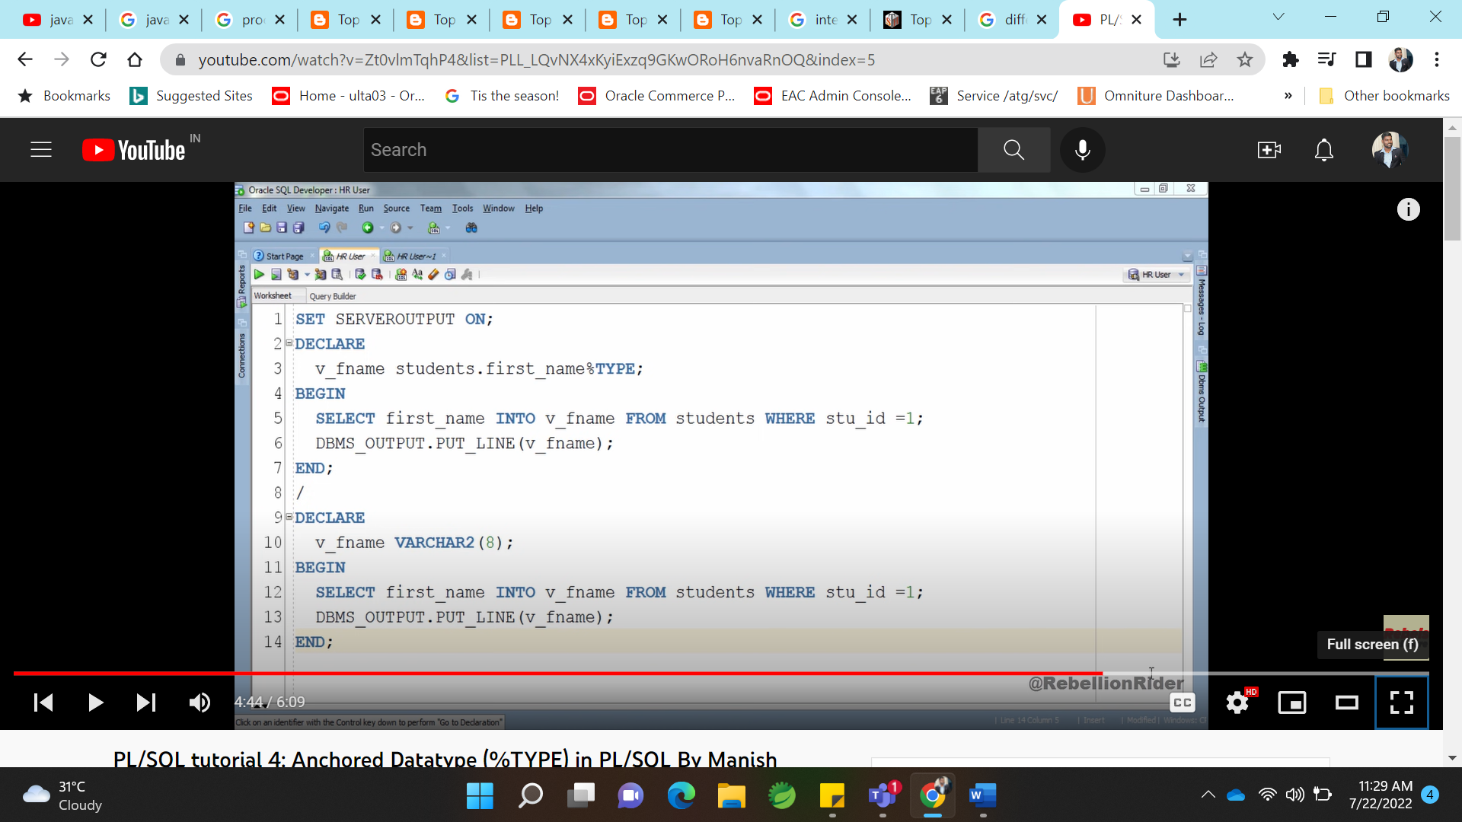

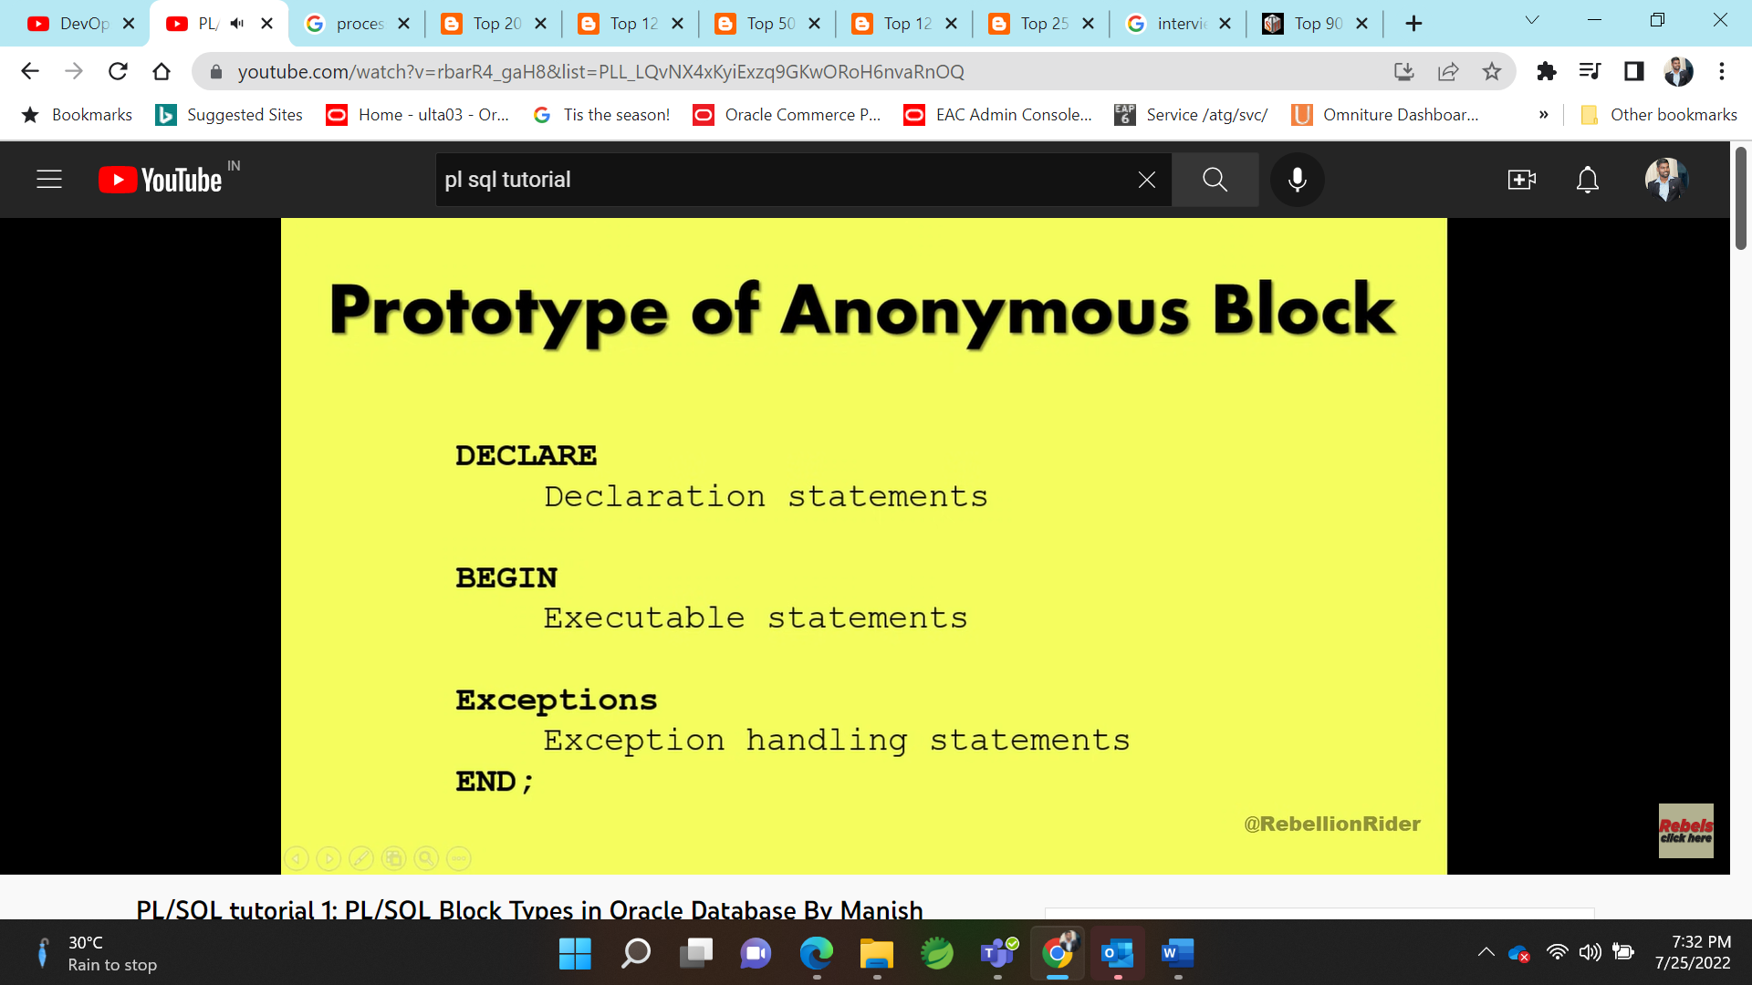

Constant declarion:

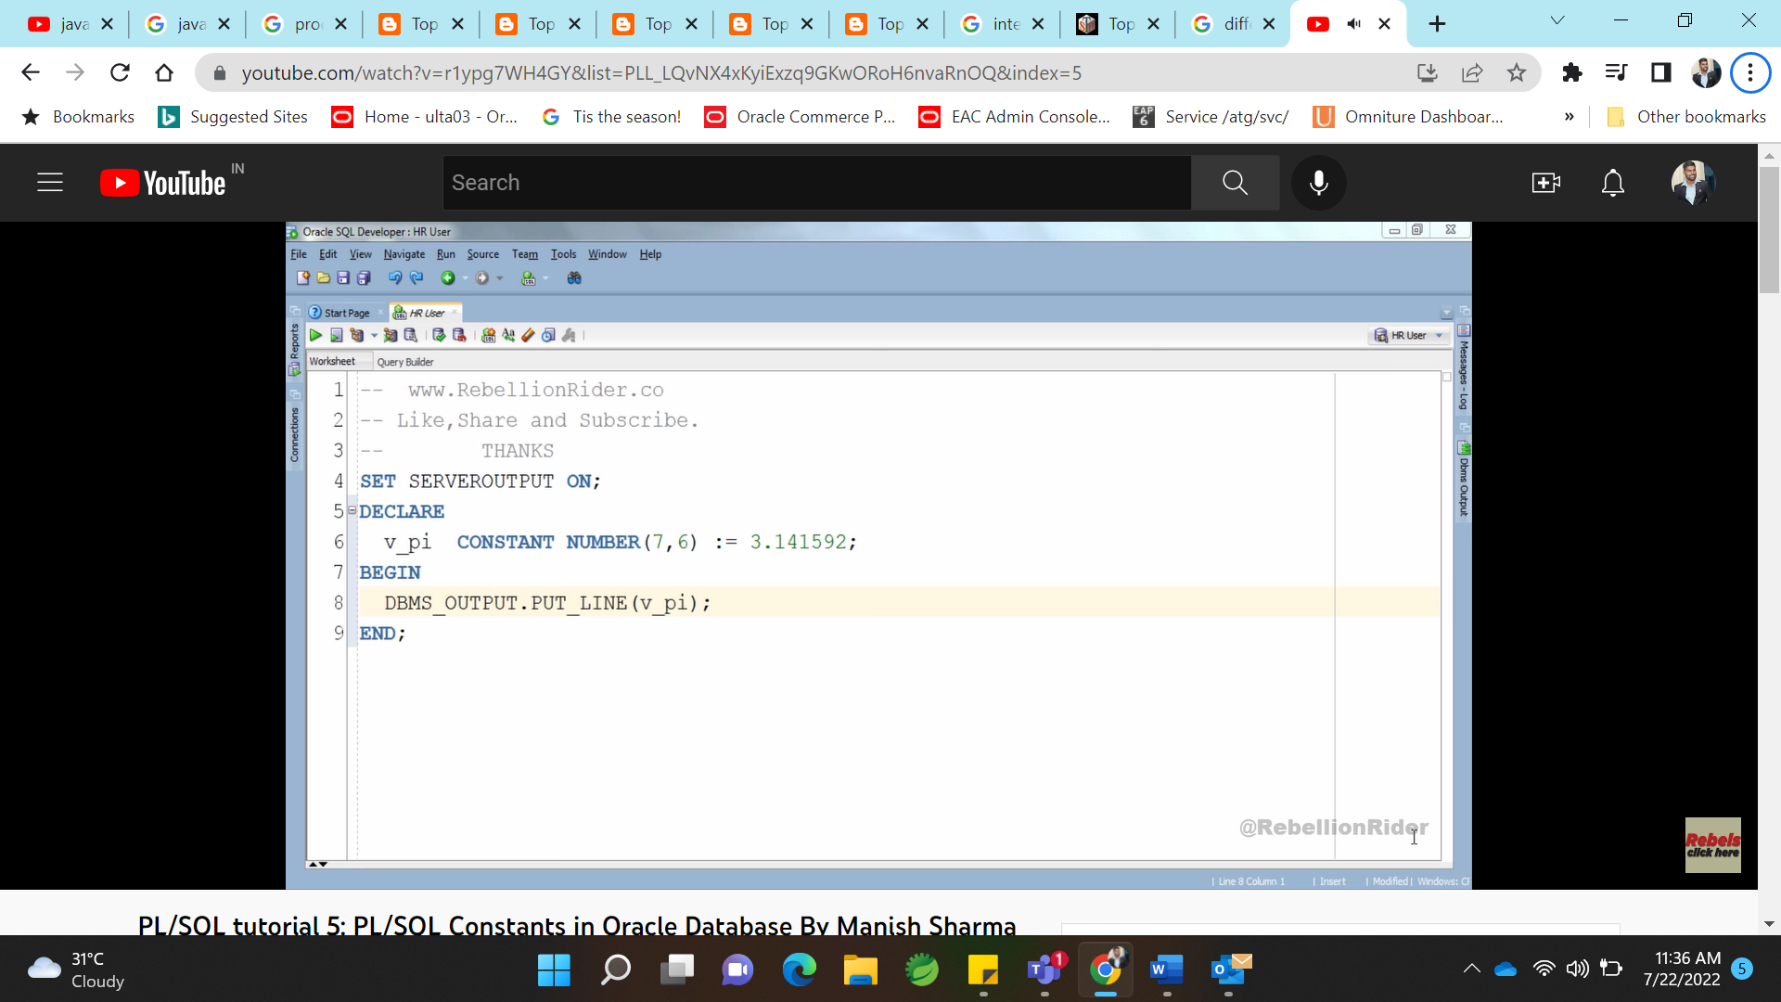

Wrong constant declaration:

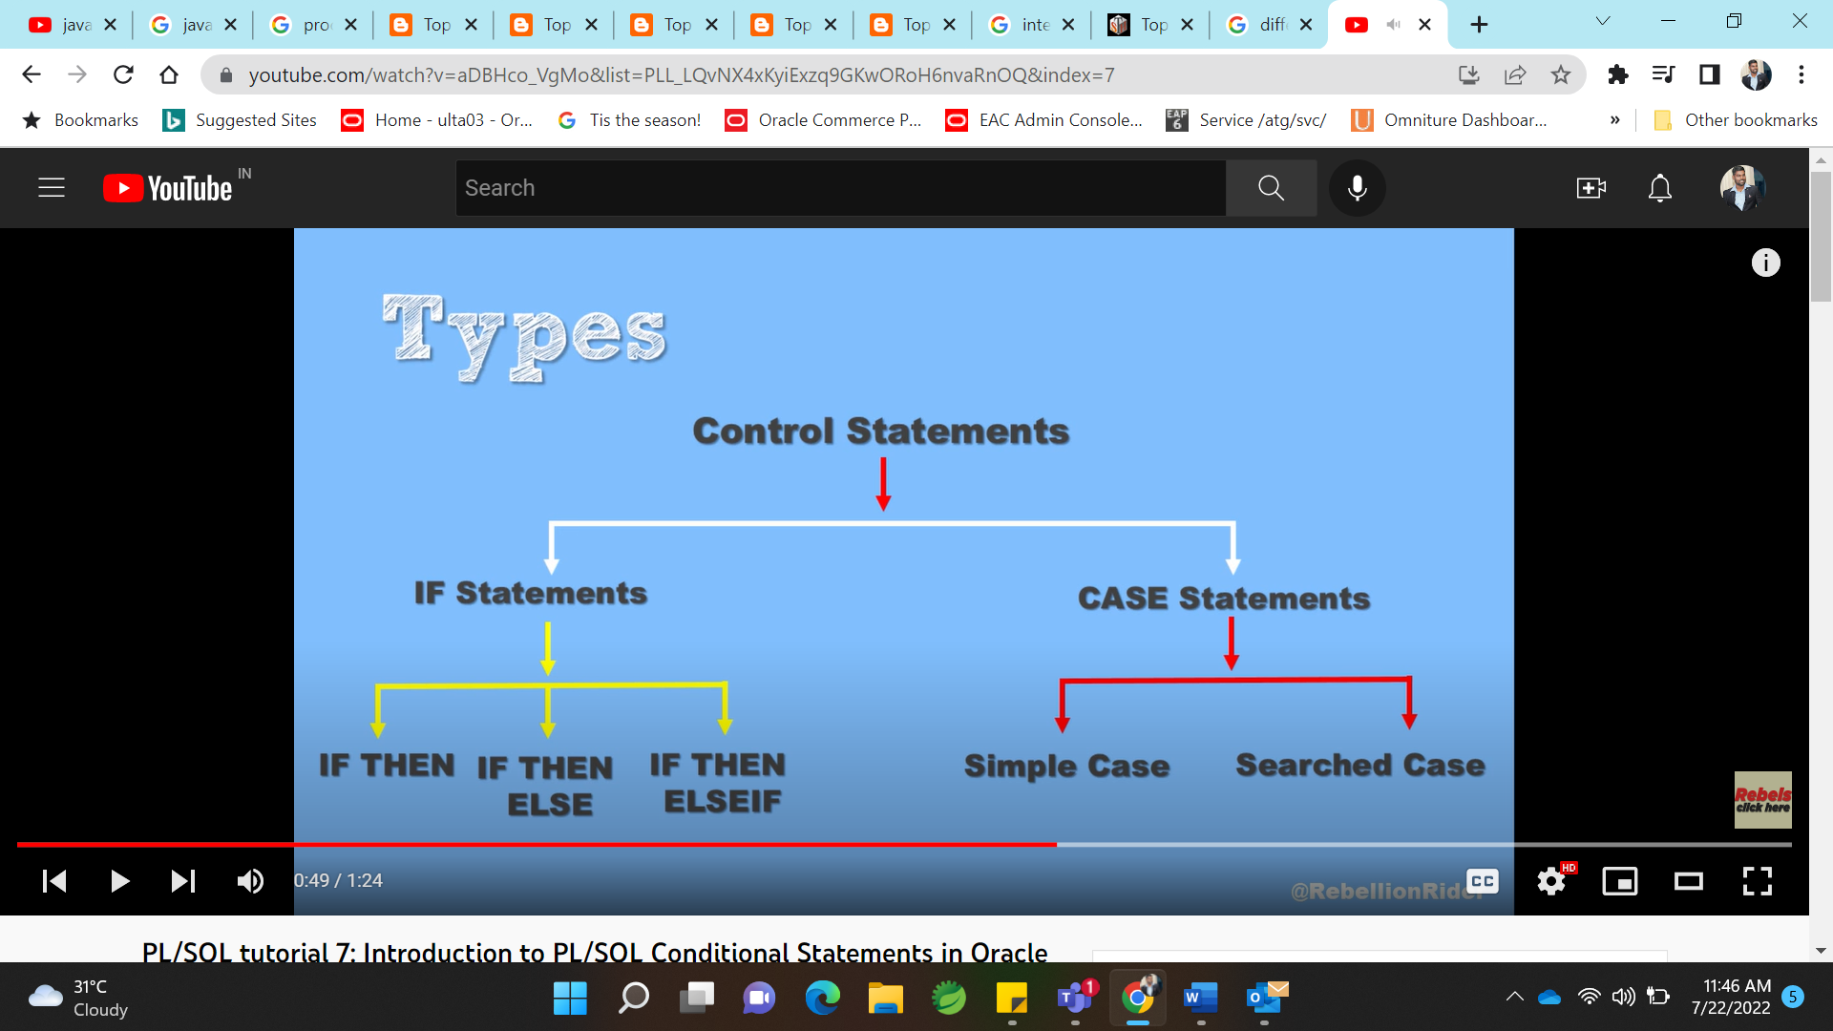

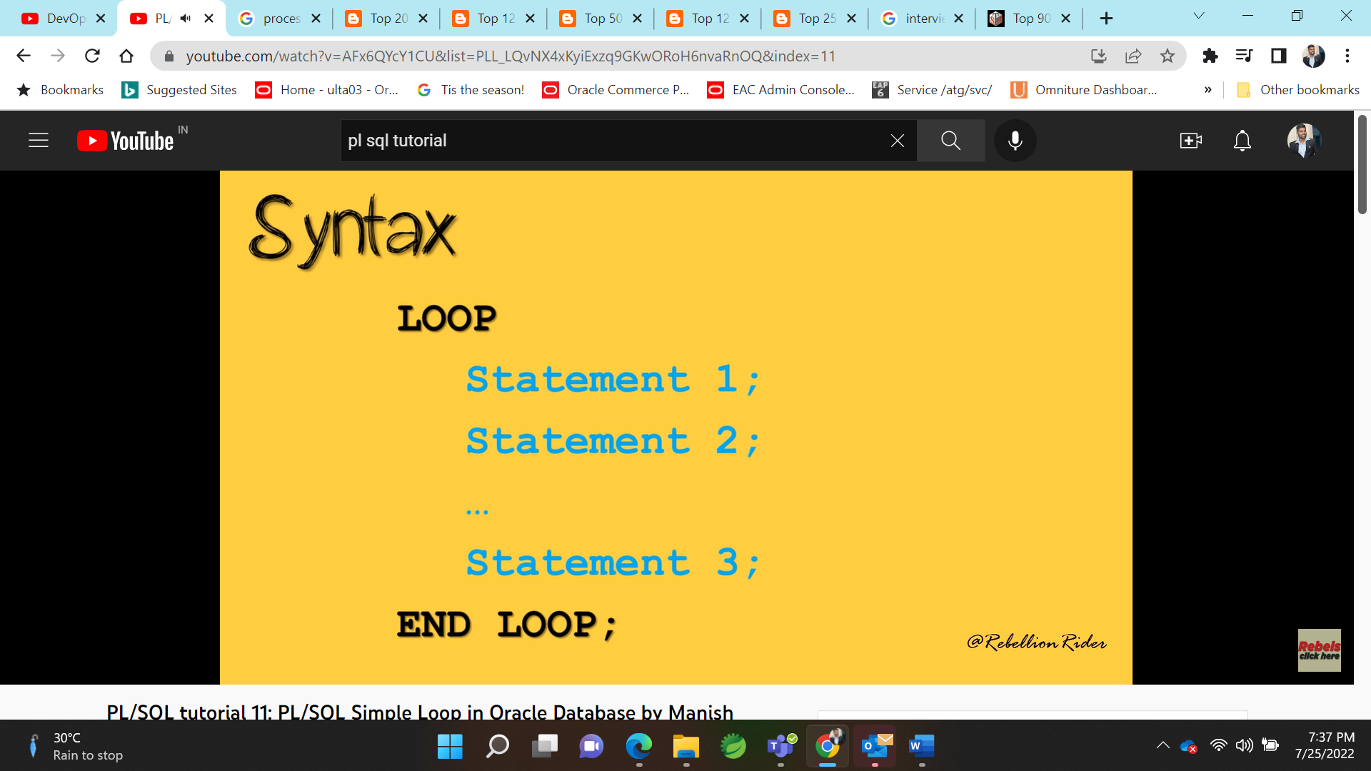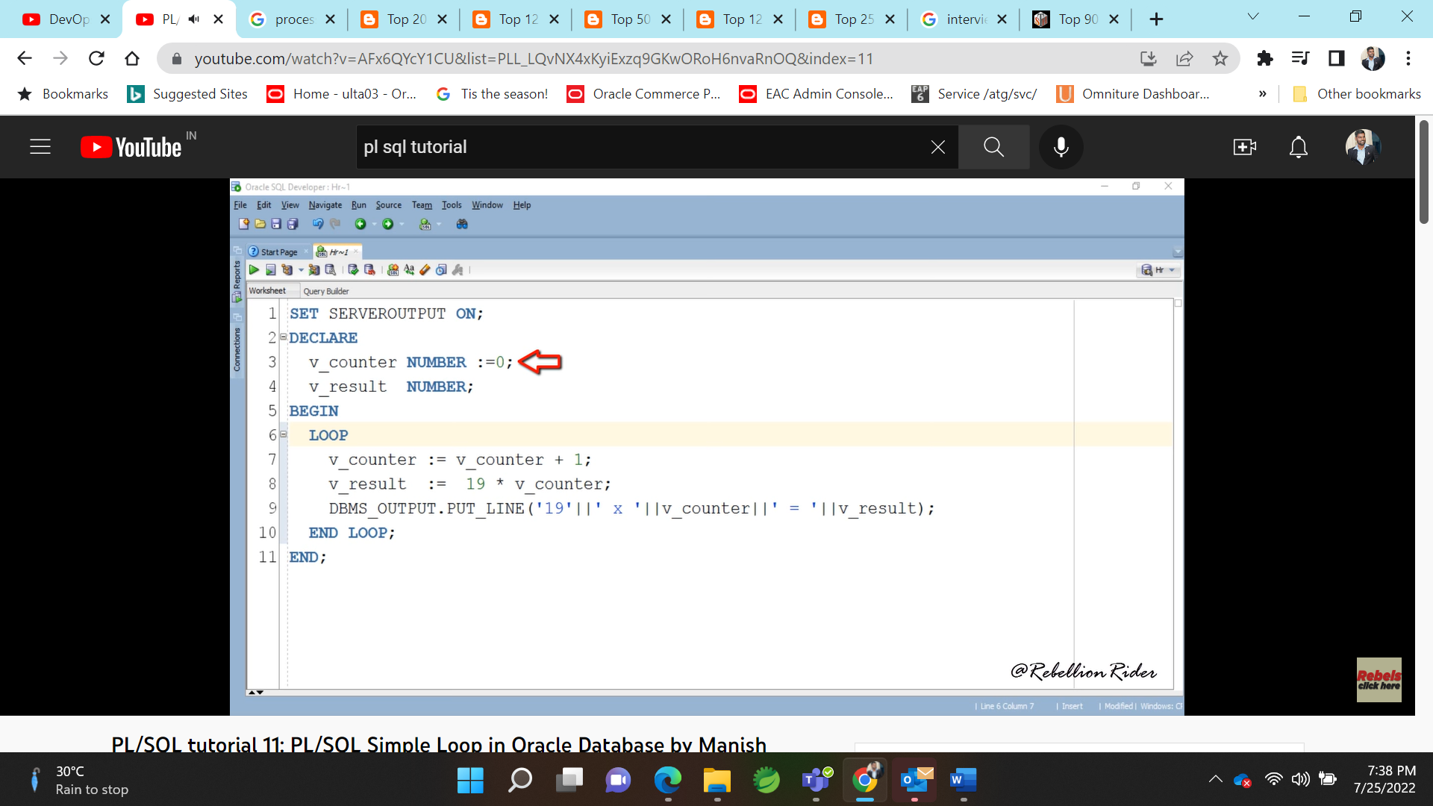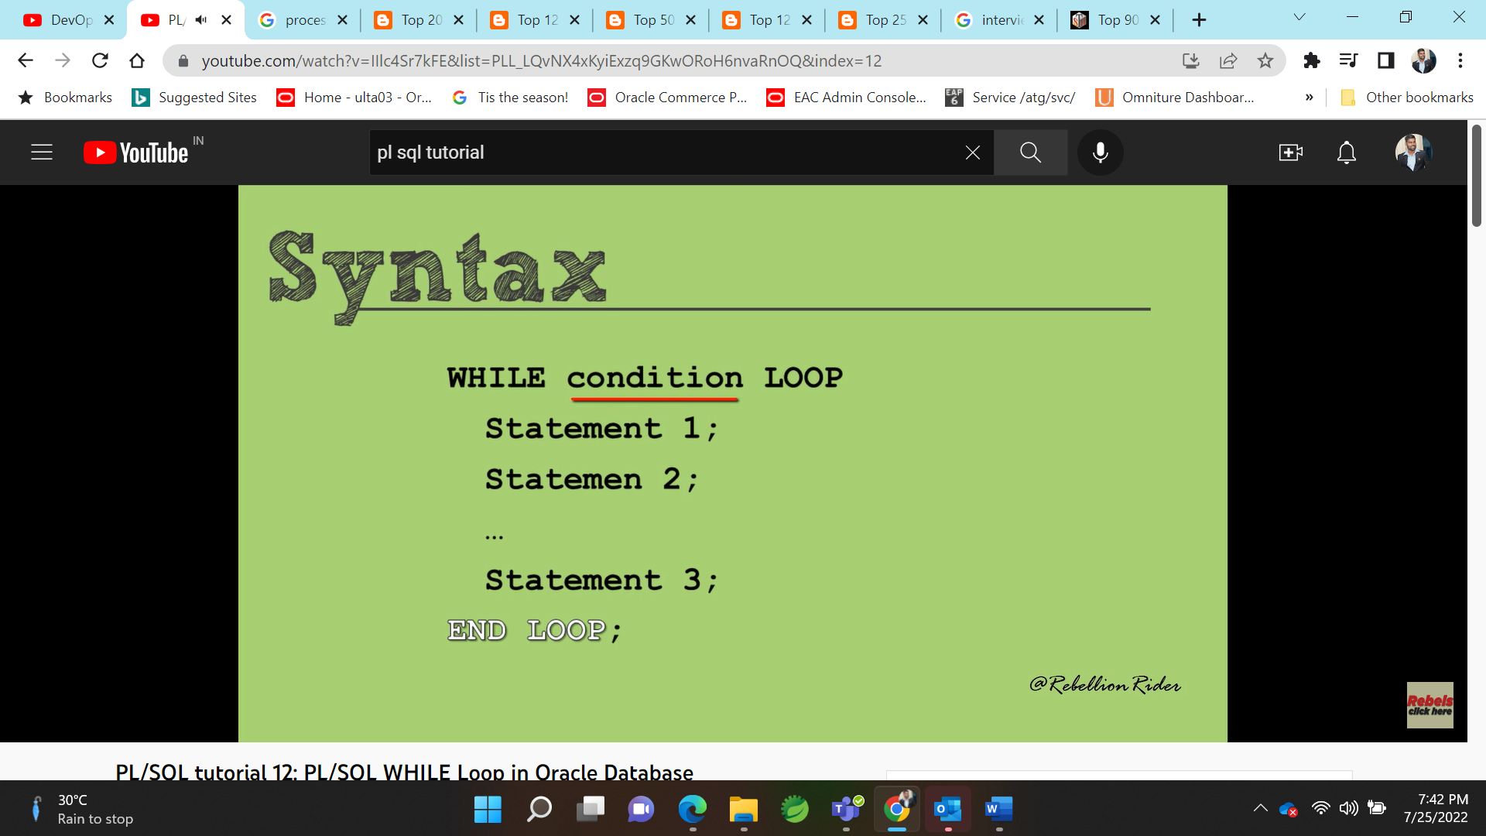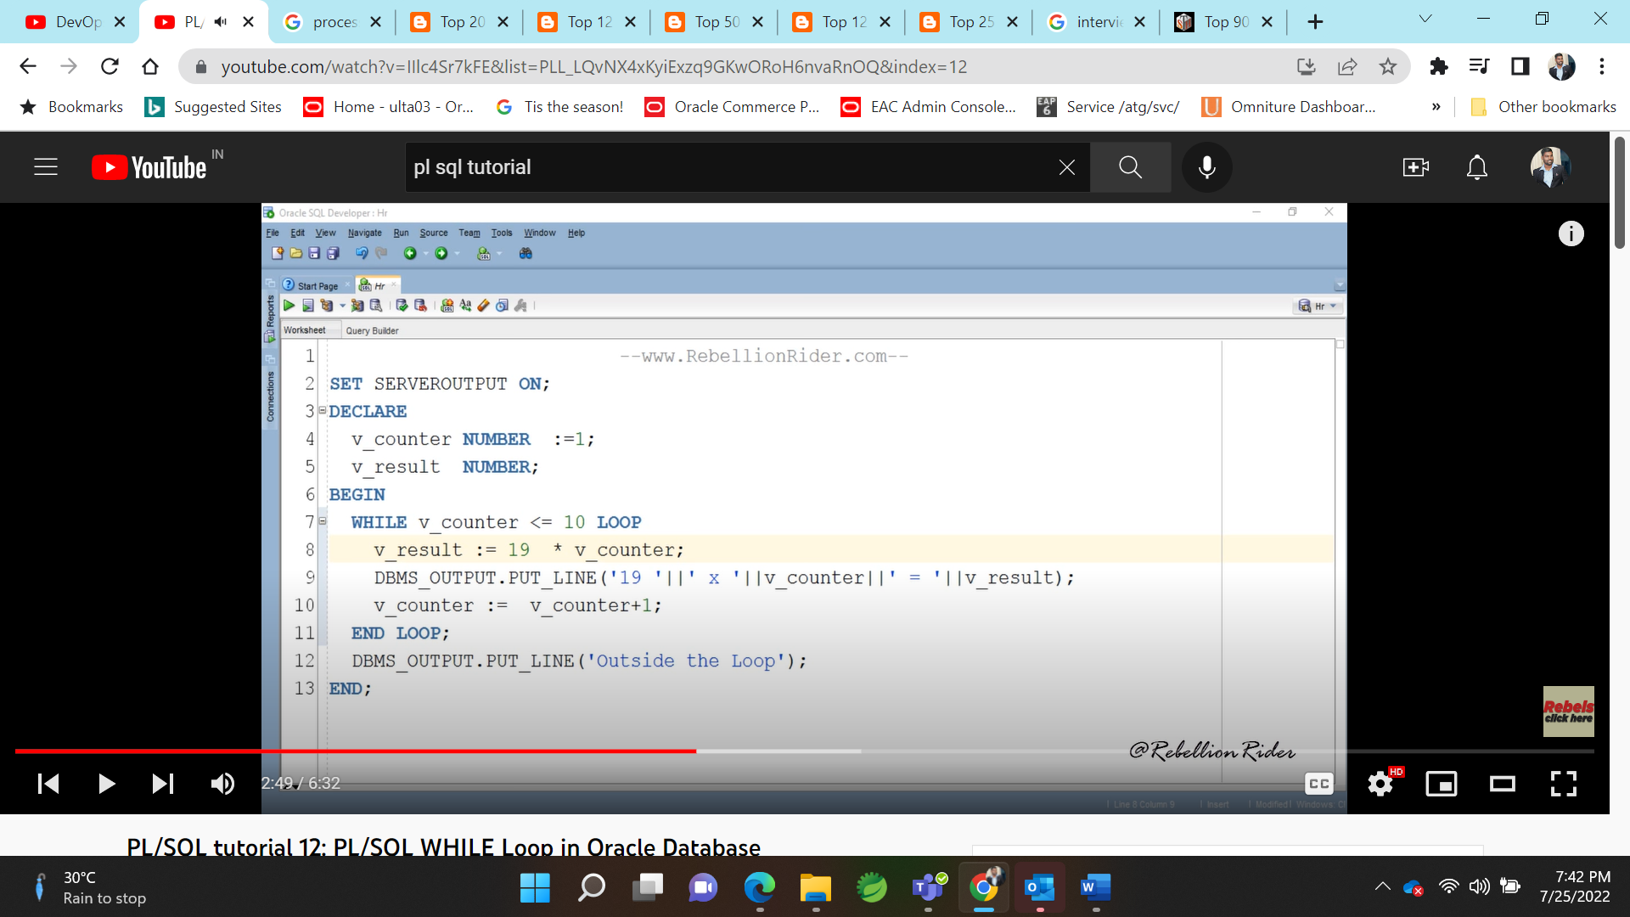

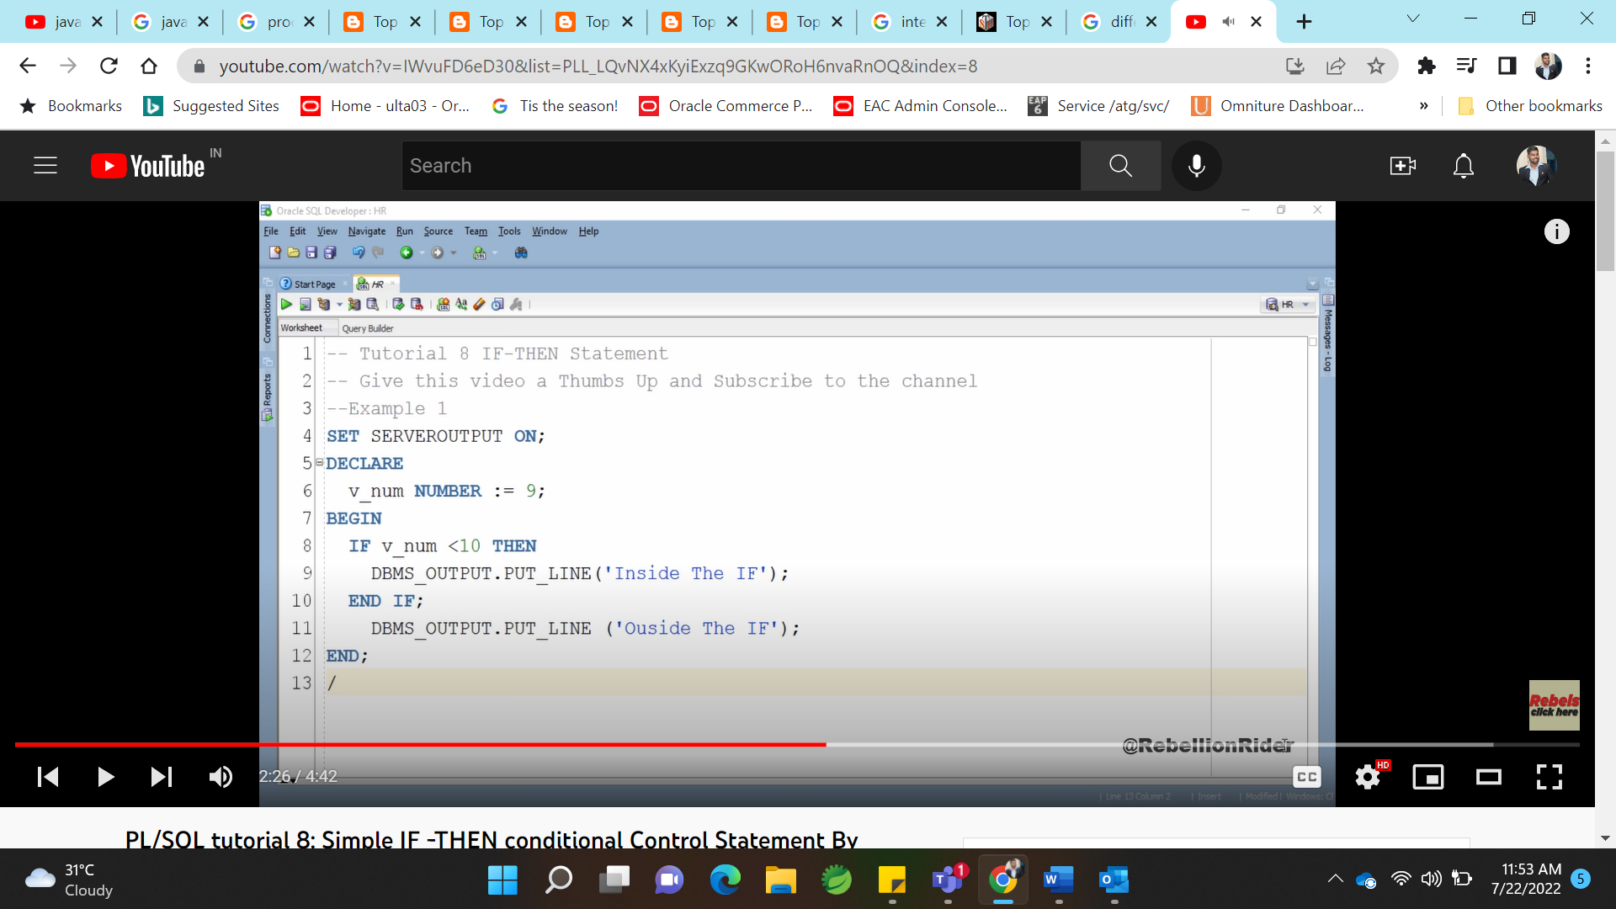

TRIGGER:

Trigger could be accessed when doing after or before(DDL or DML ) scripts

-Audit logs in Audit table which DML operation is done.

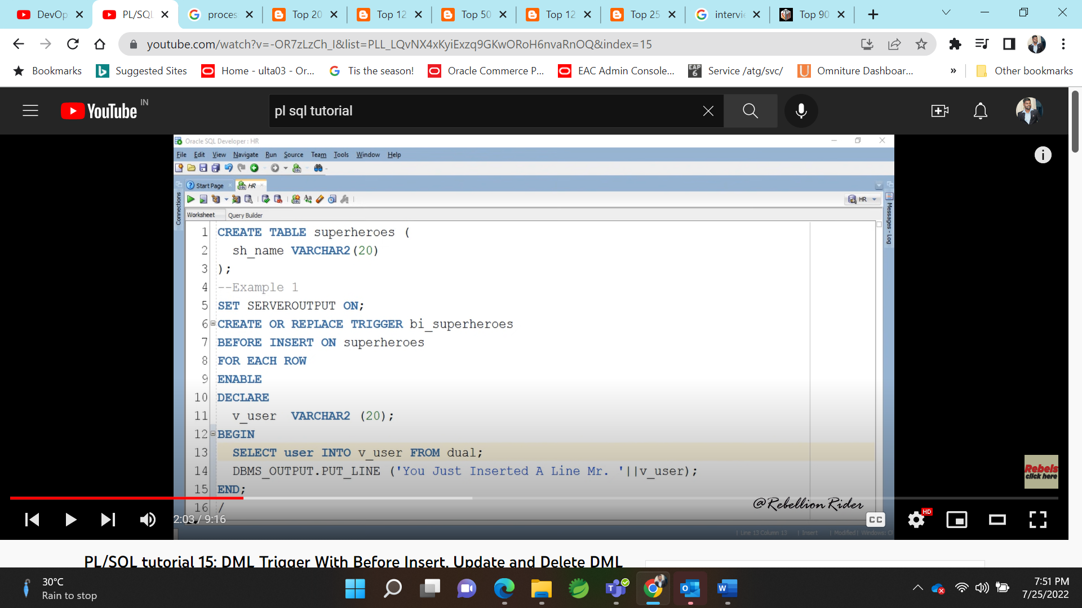

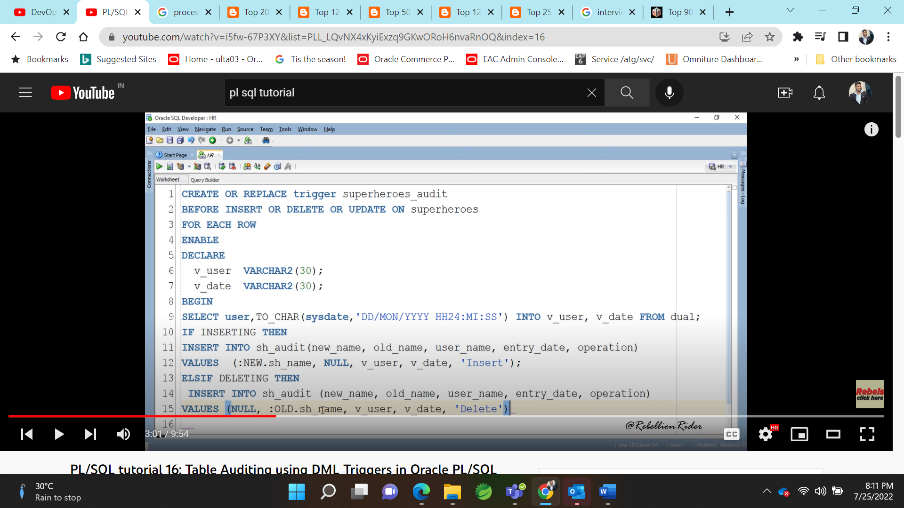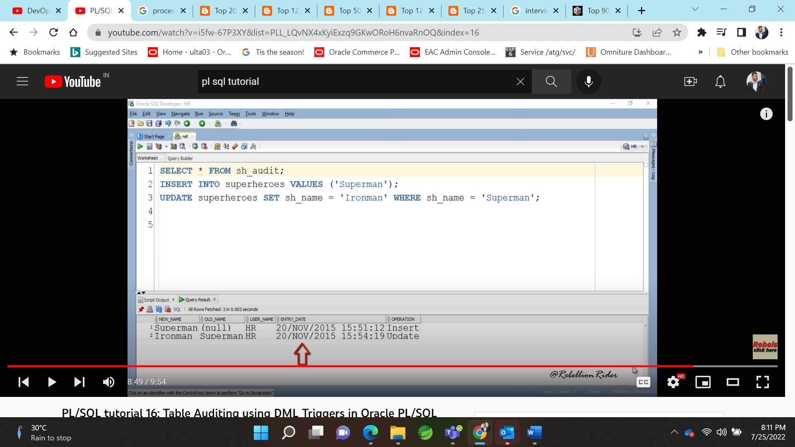

Cursor:

Cursor : point of area in memory

Types : implicit and explicit cursor.

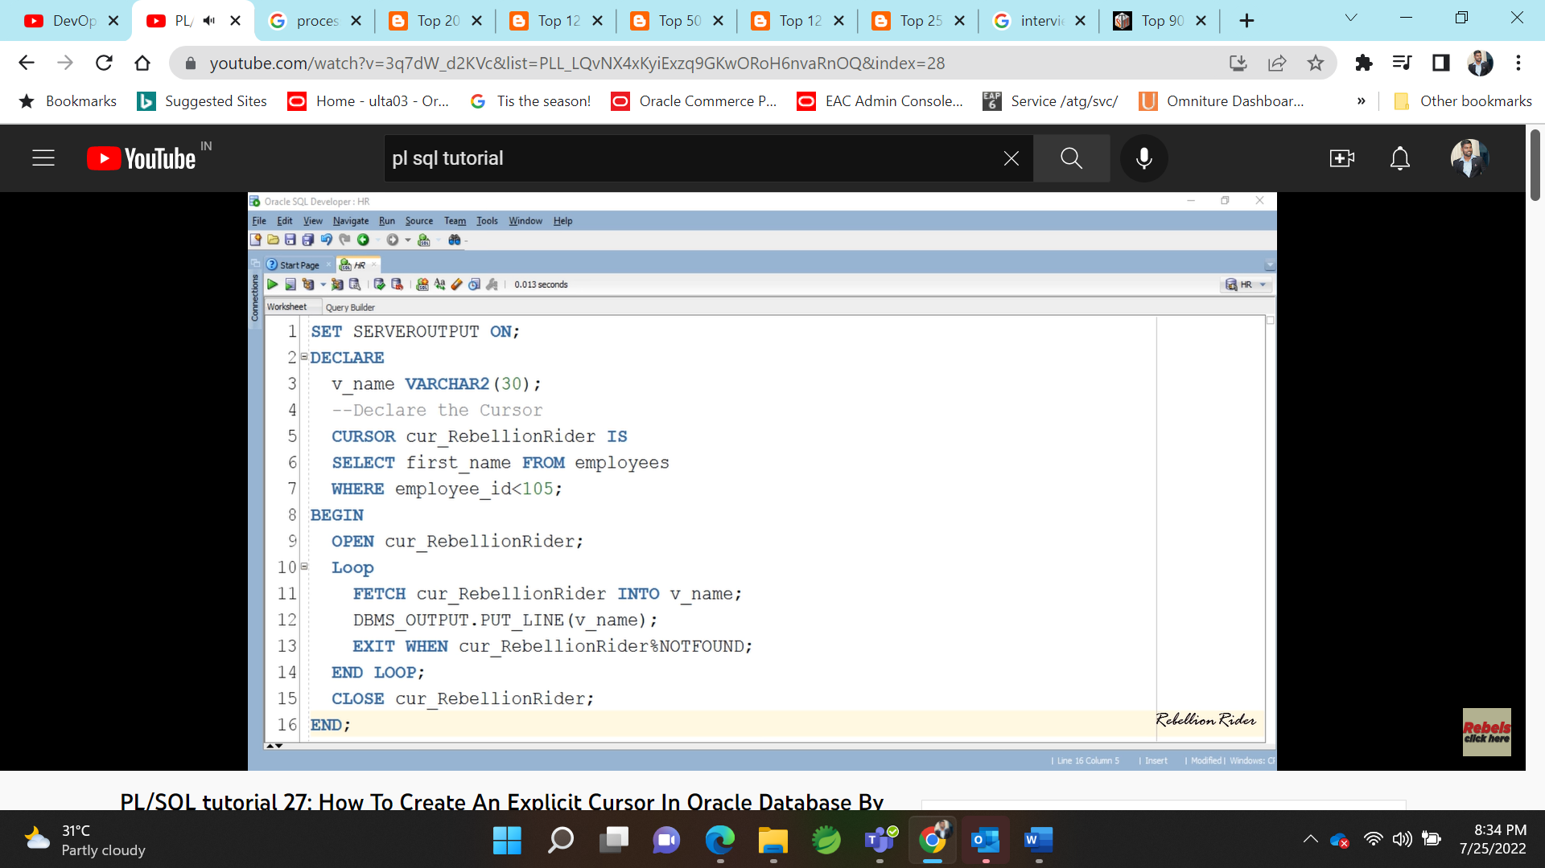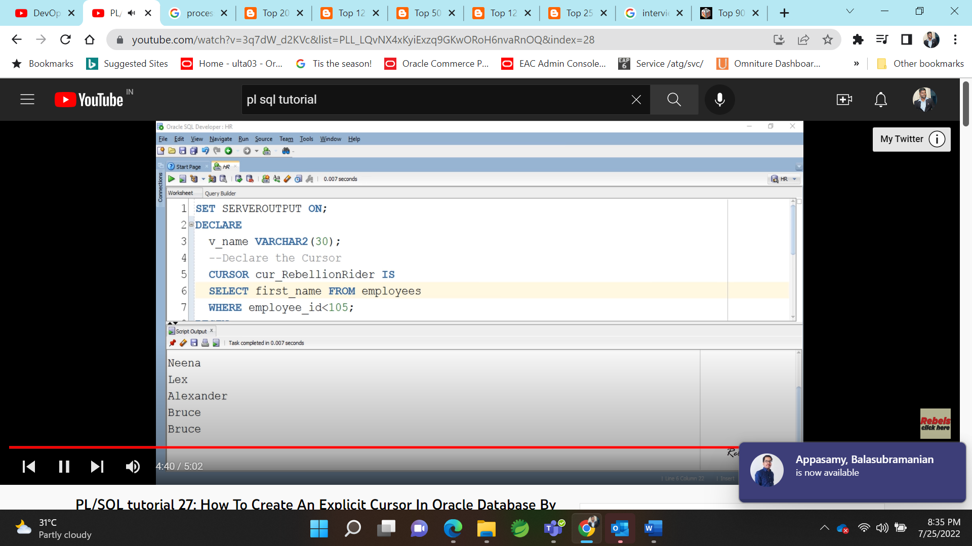

Parameterized cursor;

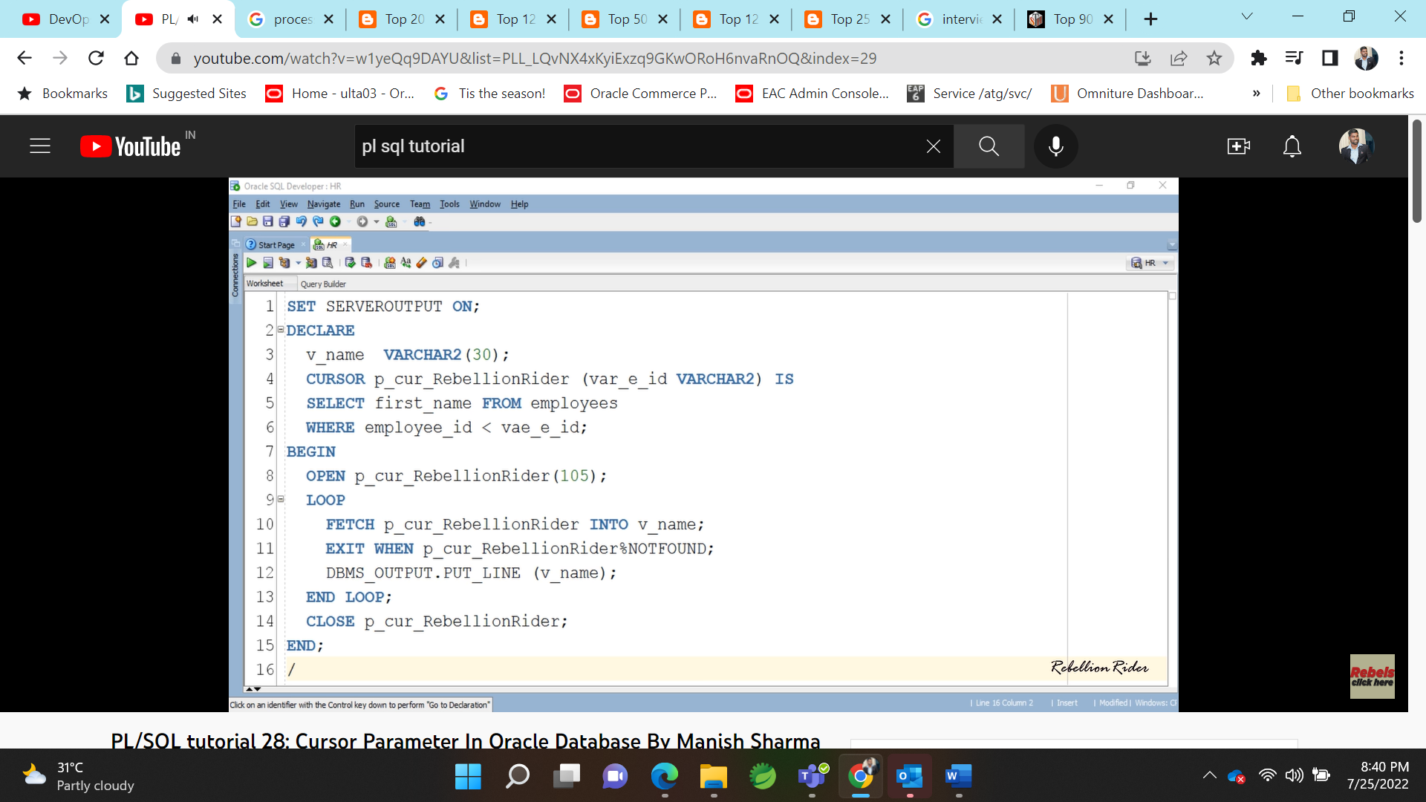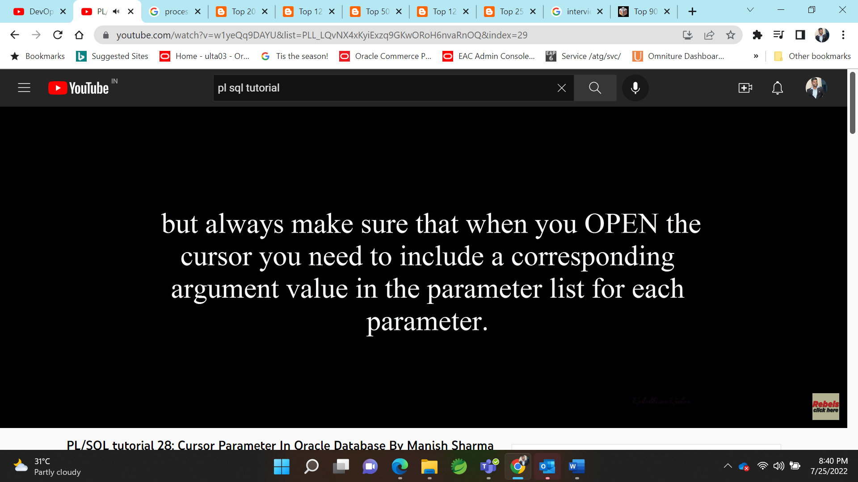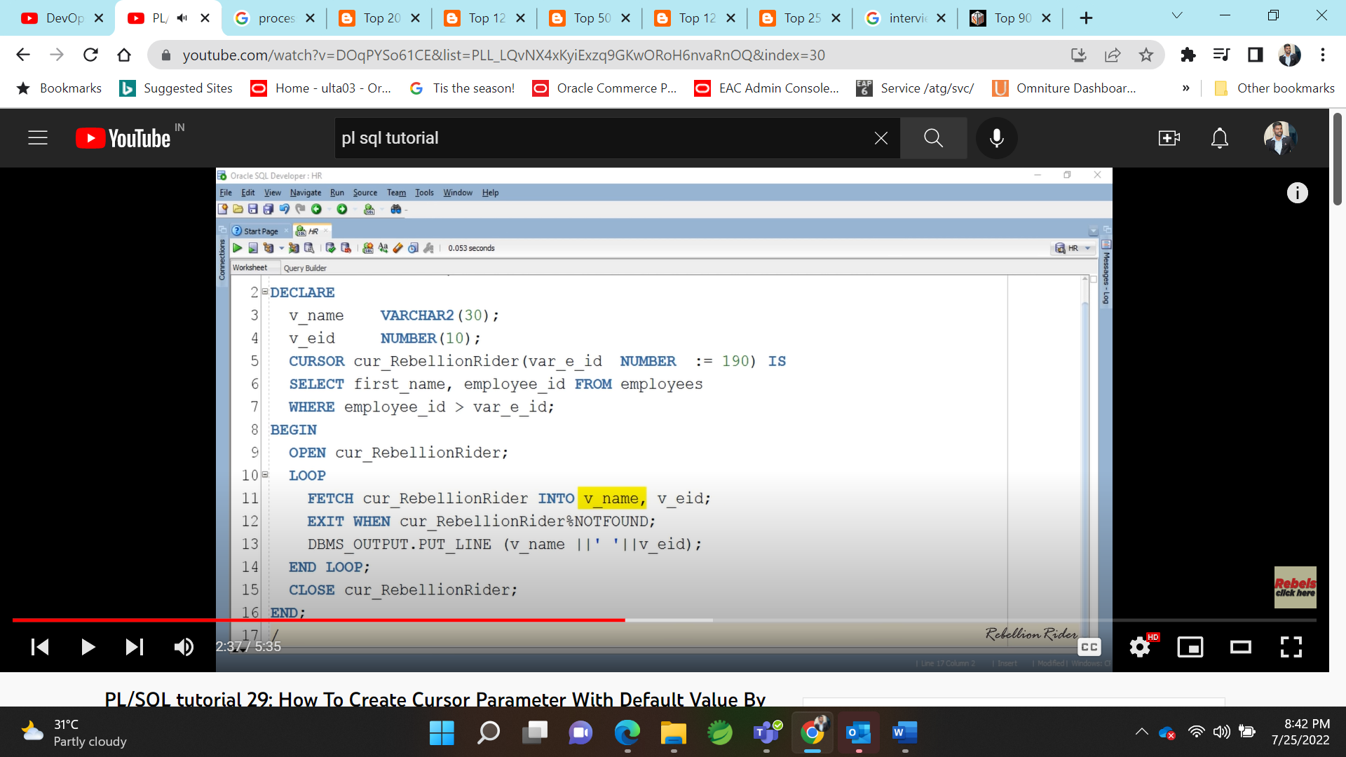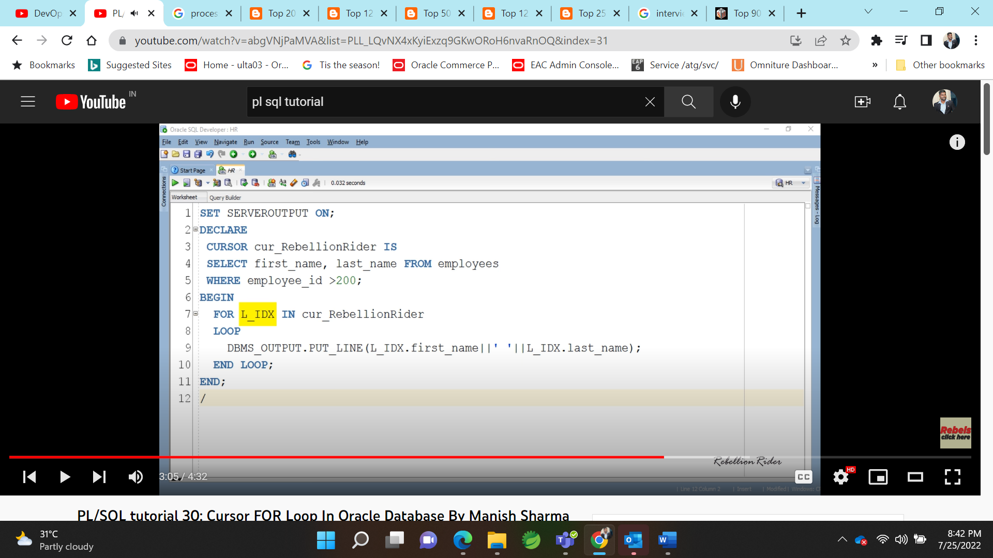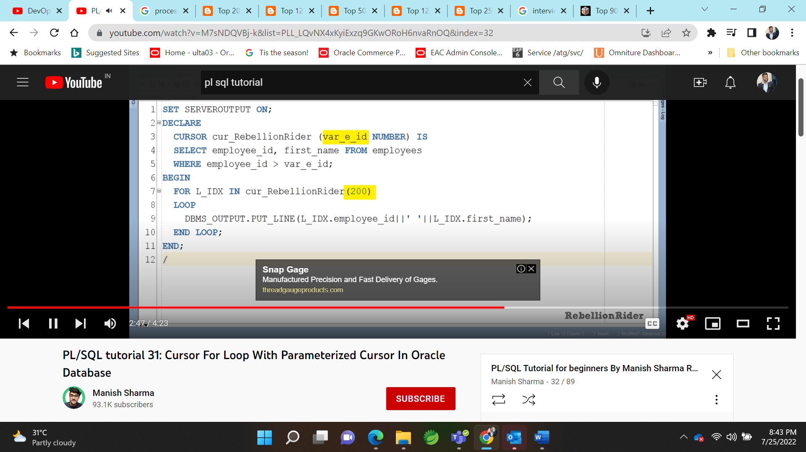

**Datatypes : Anchored Data type and Row Data type:** 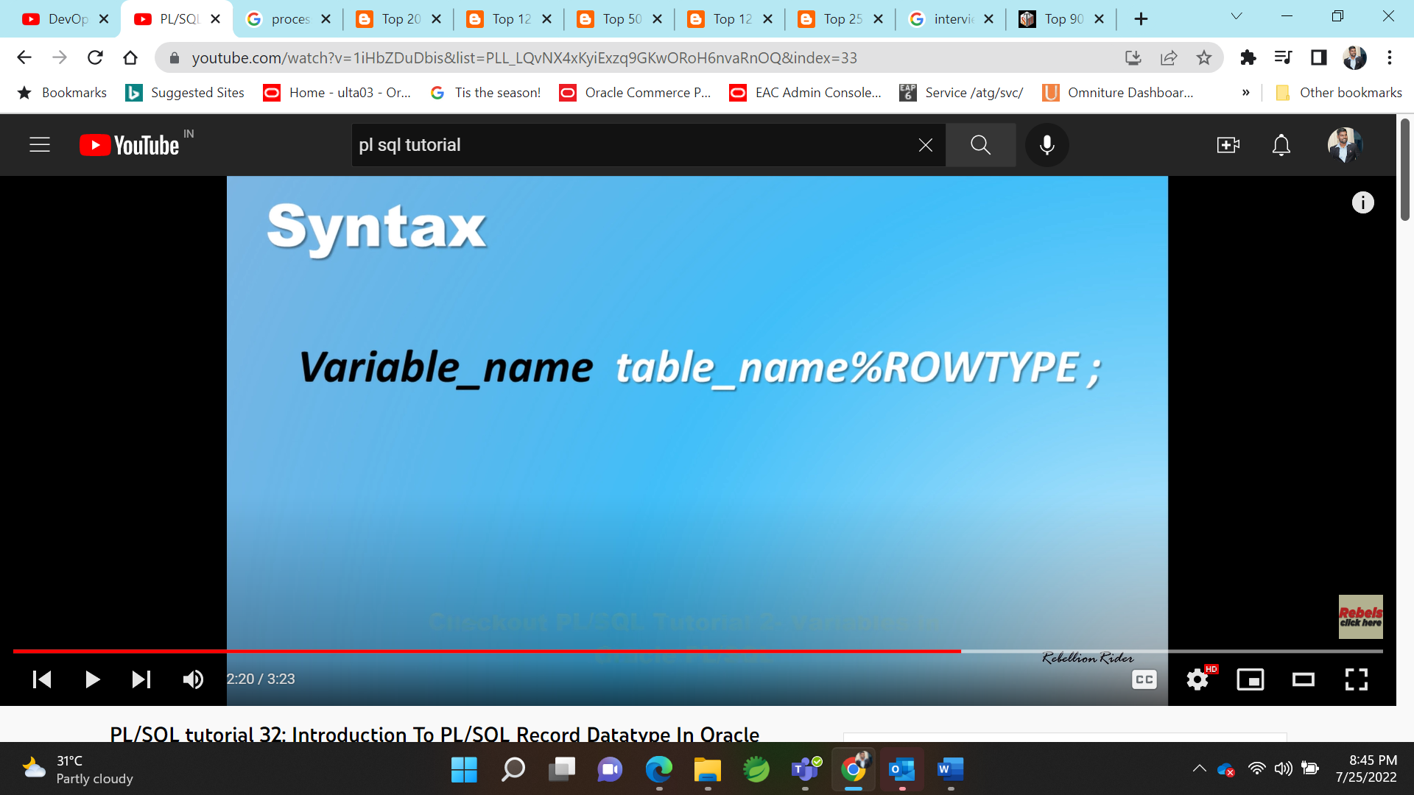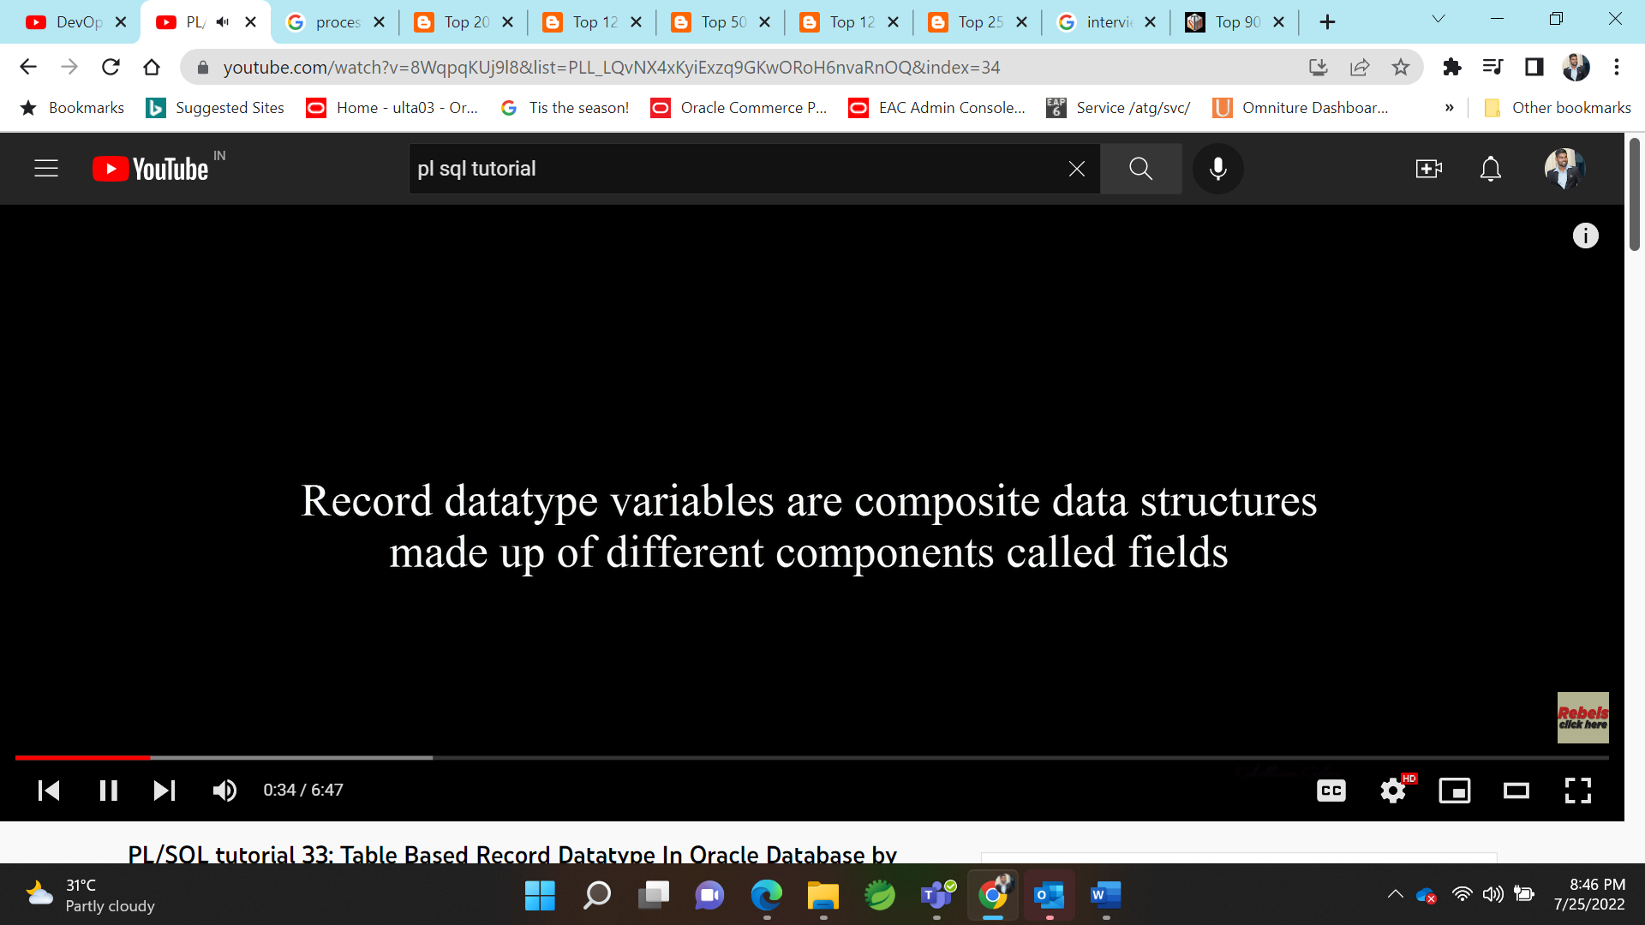

Row type:

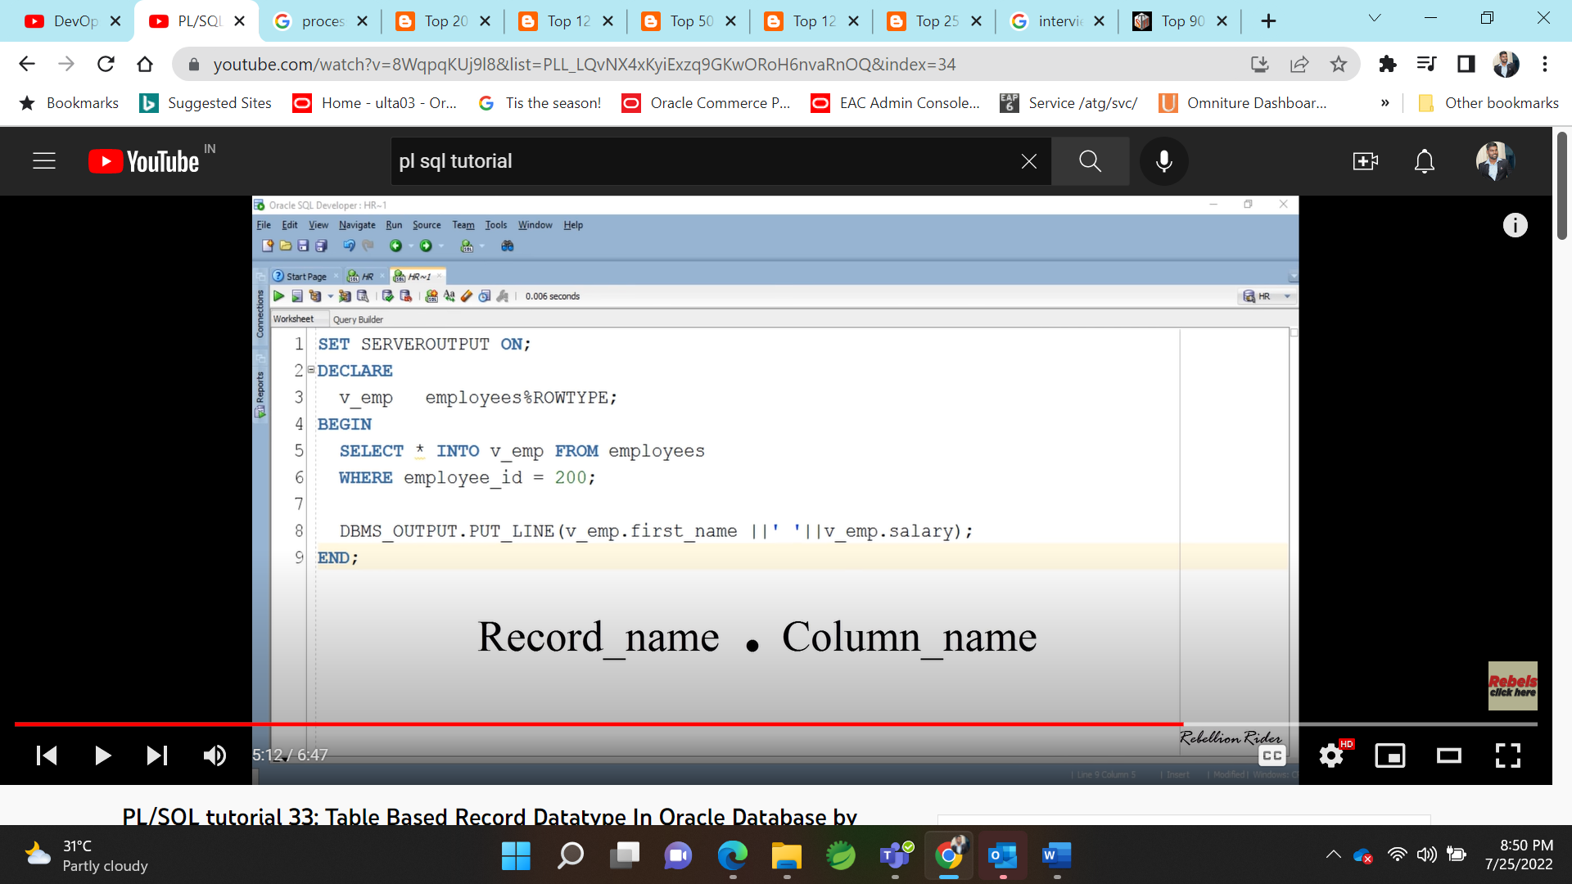

**Functions:** 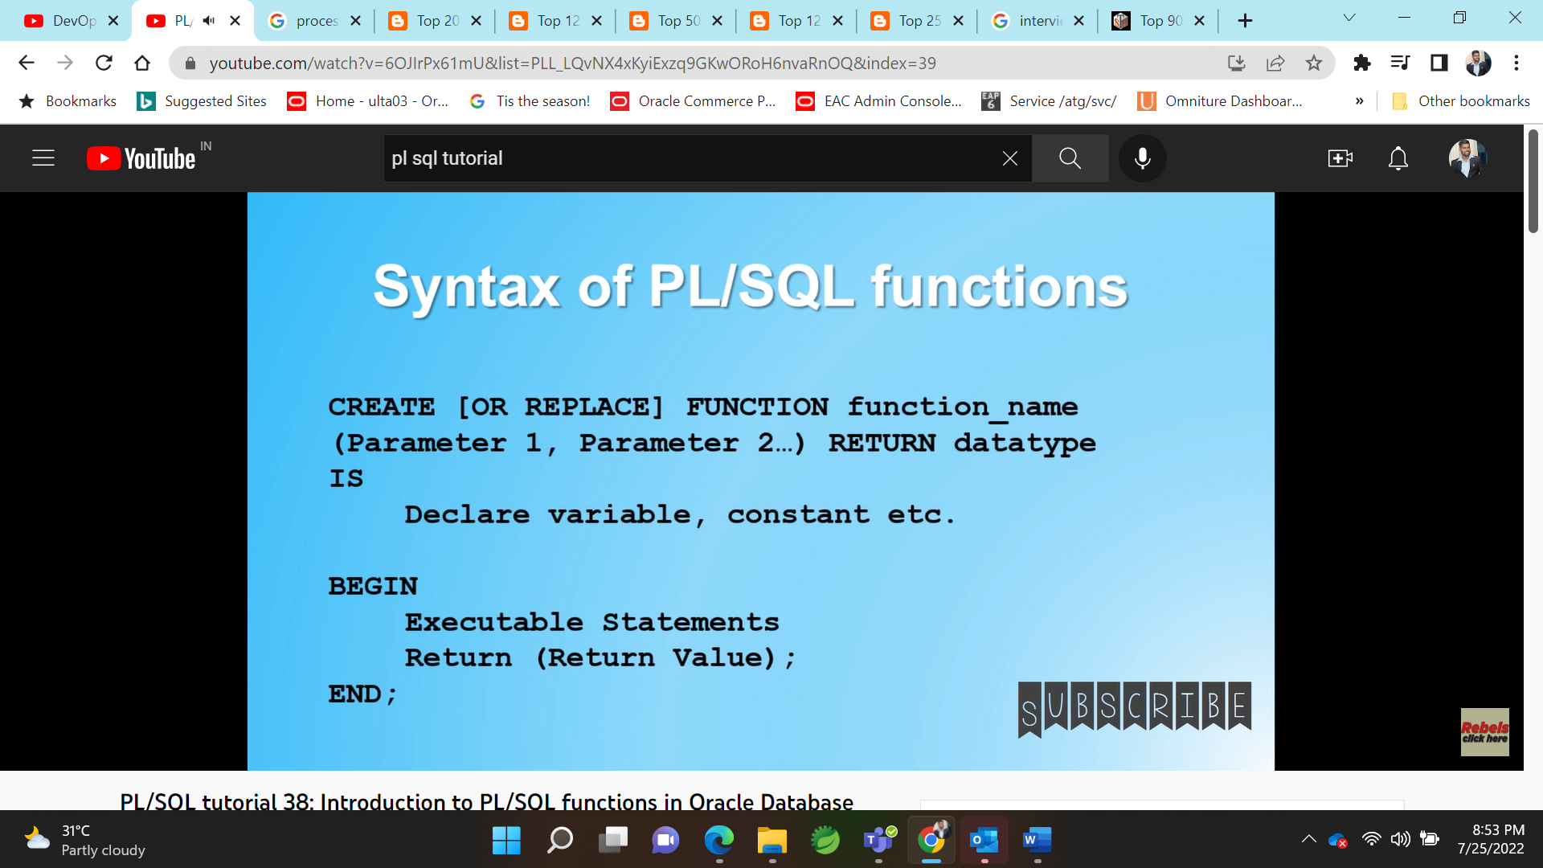

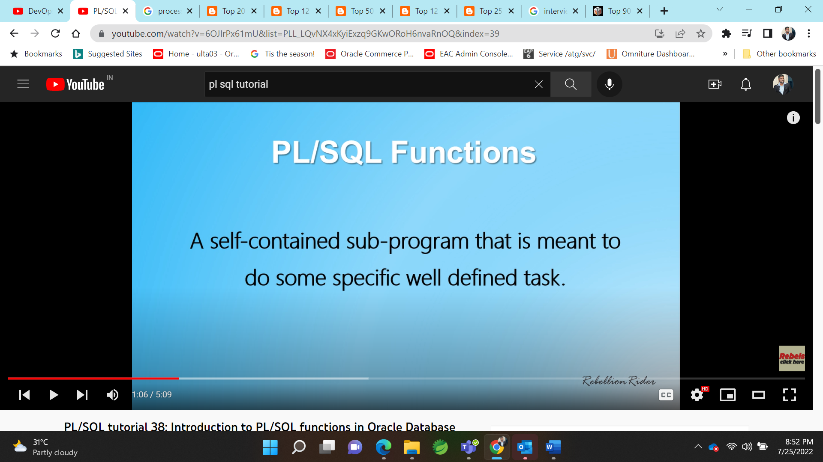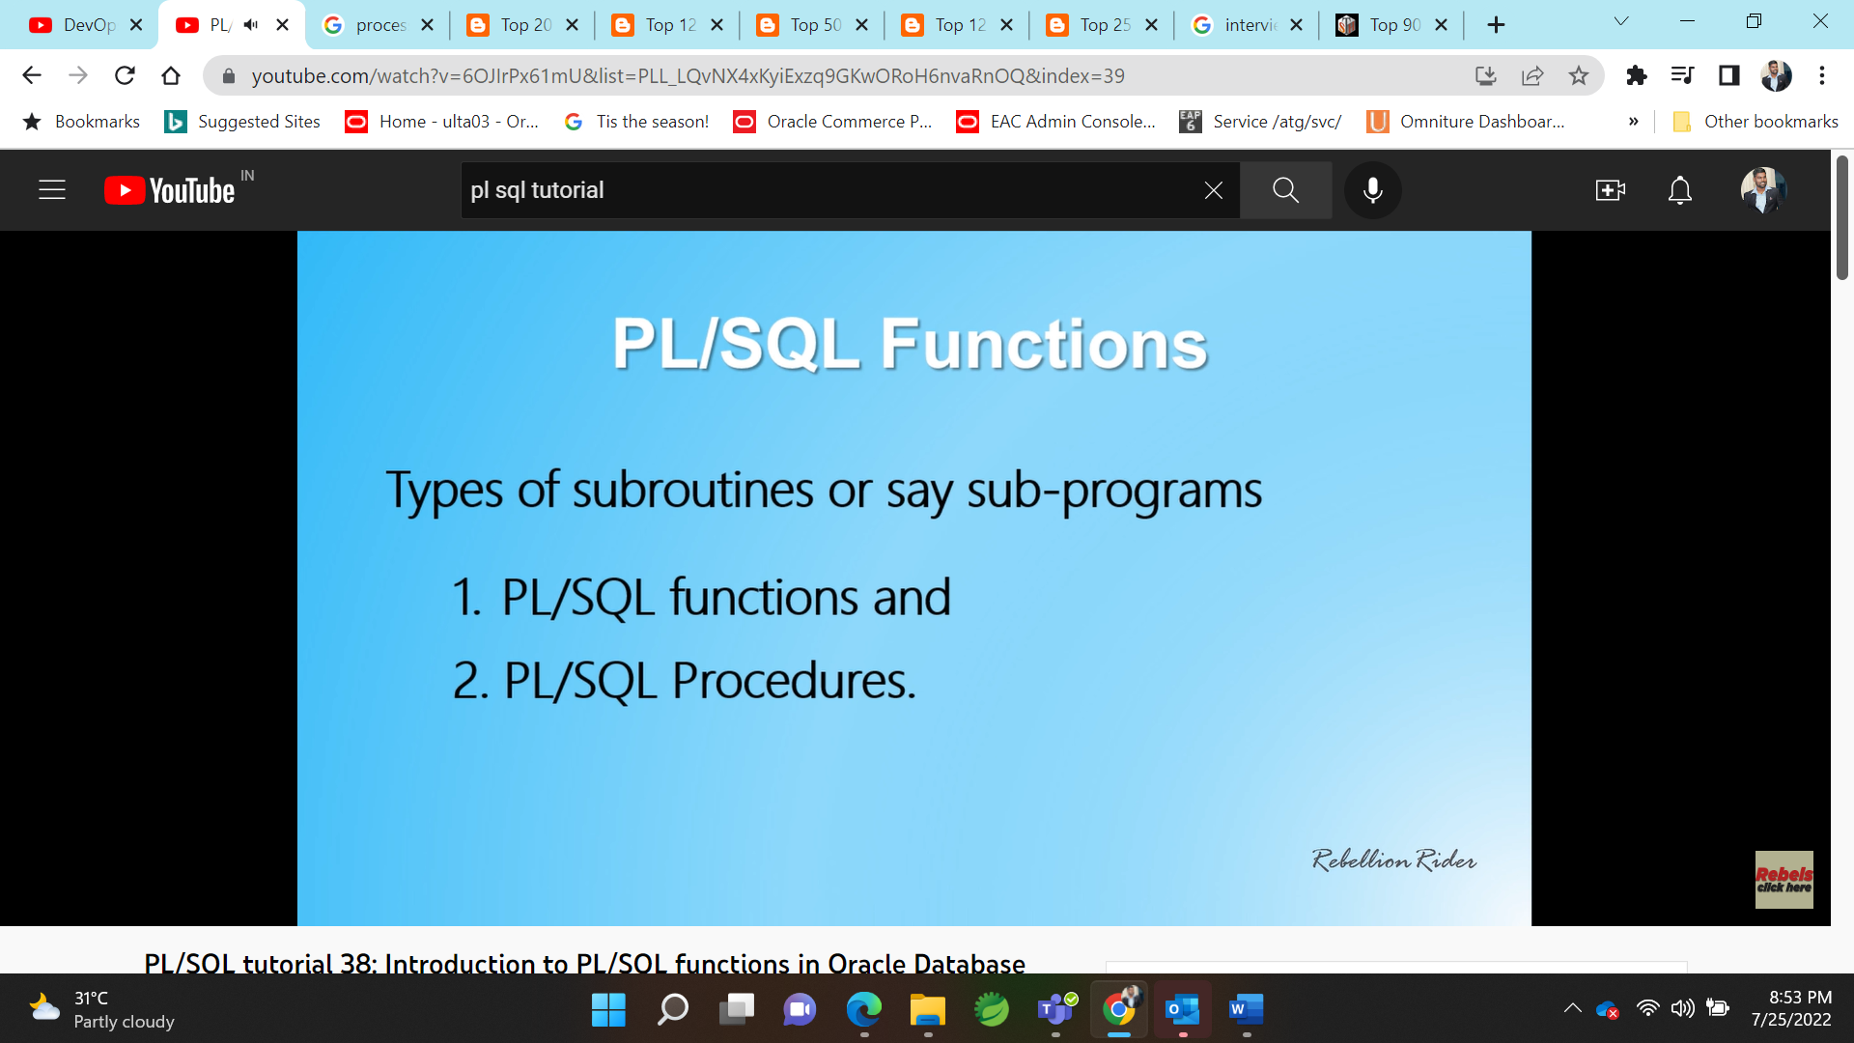

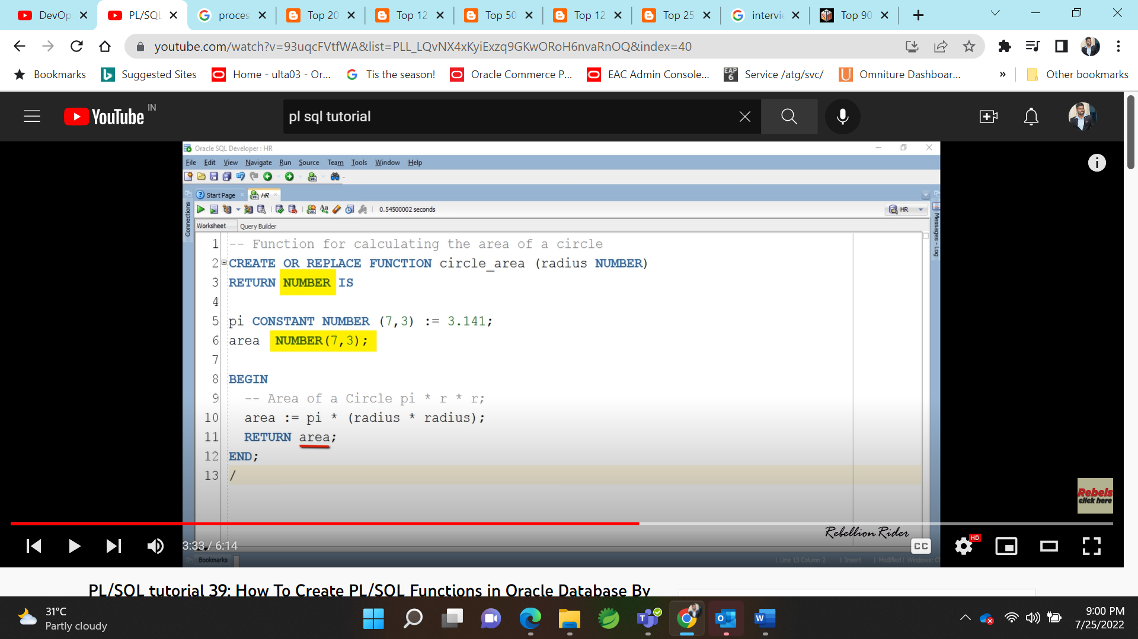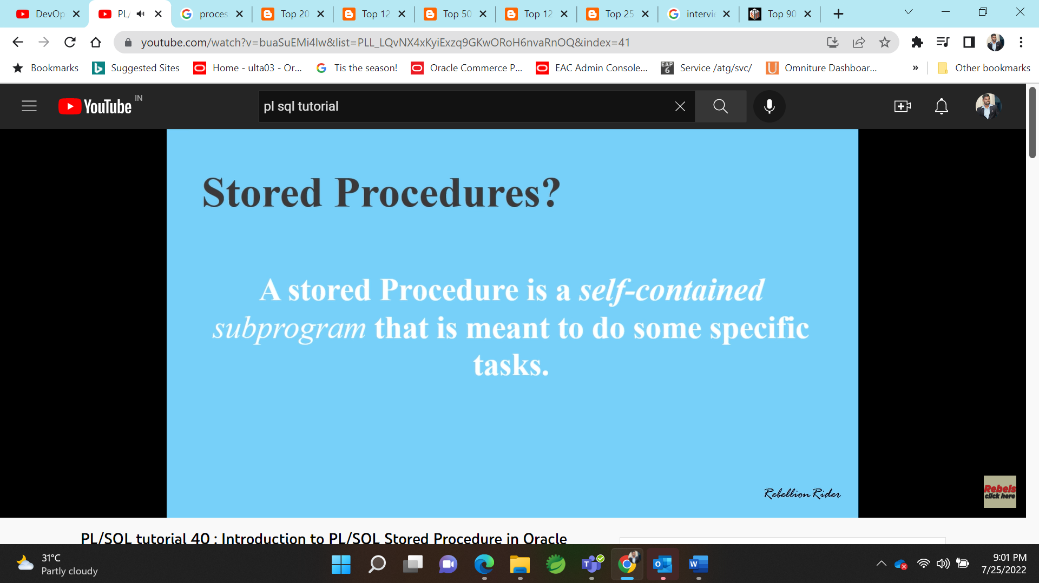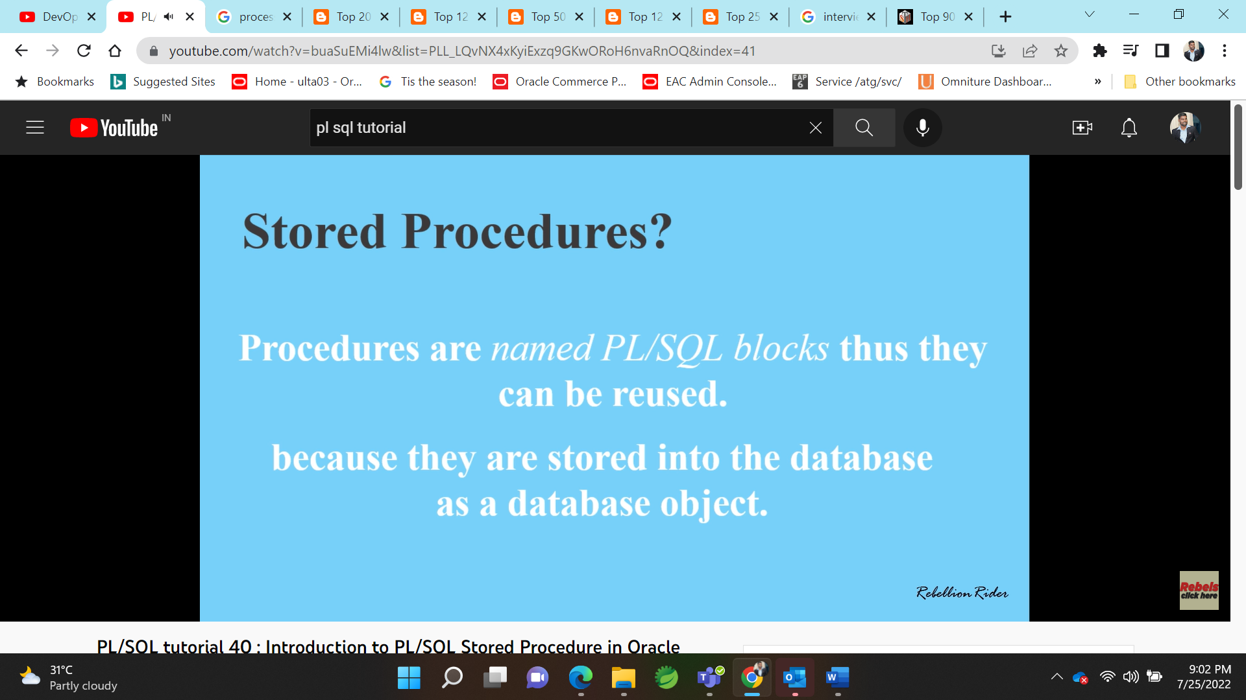

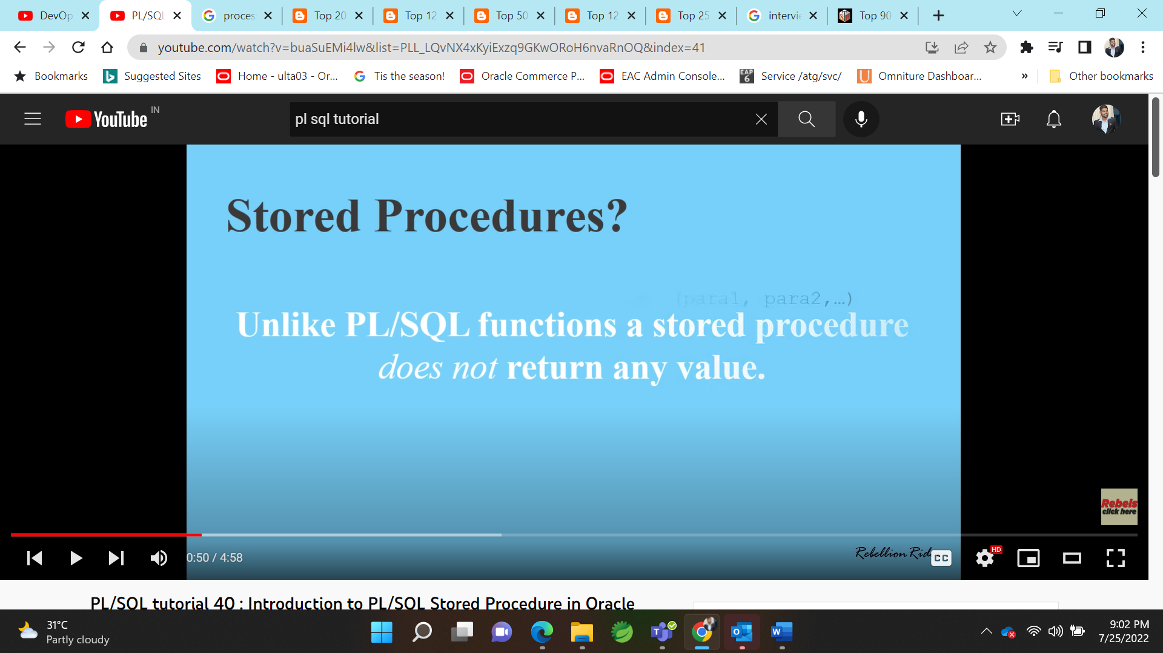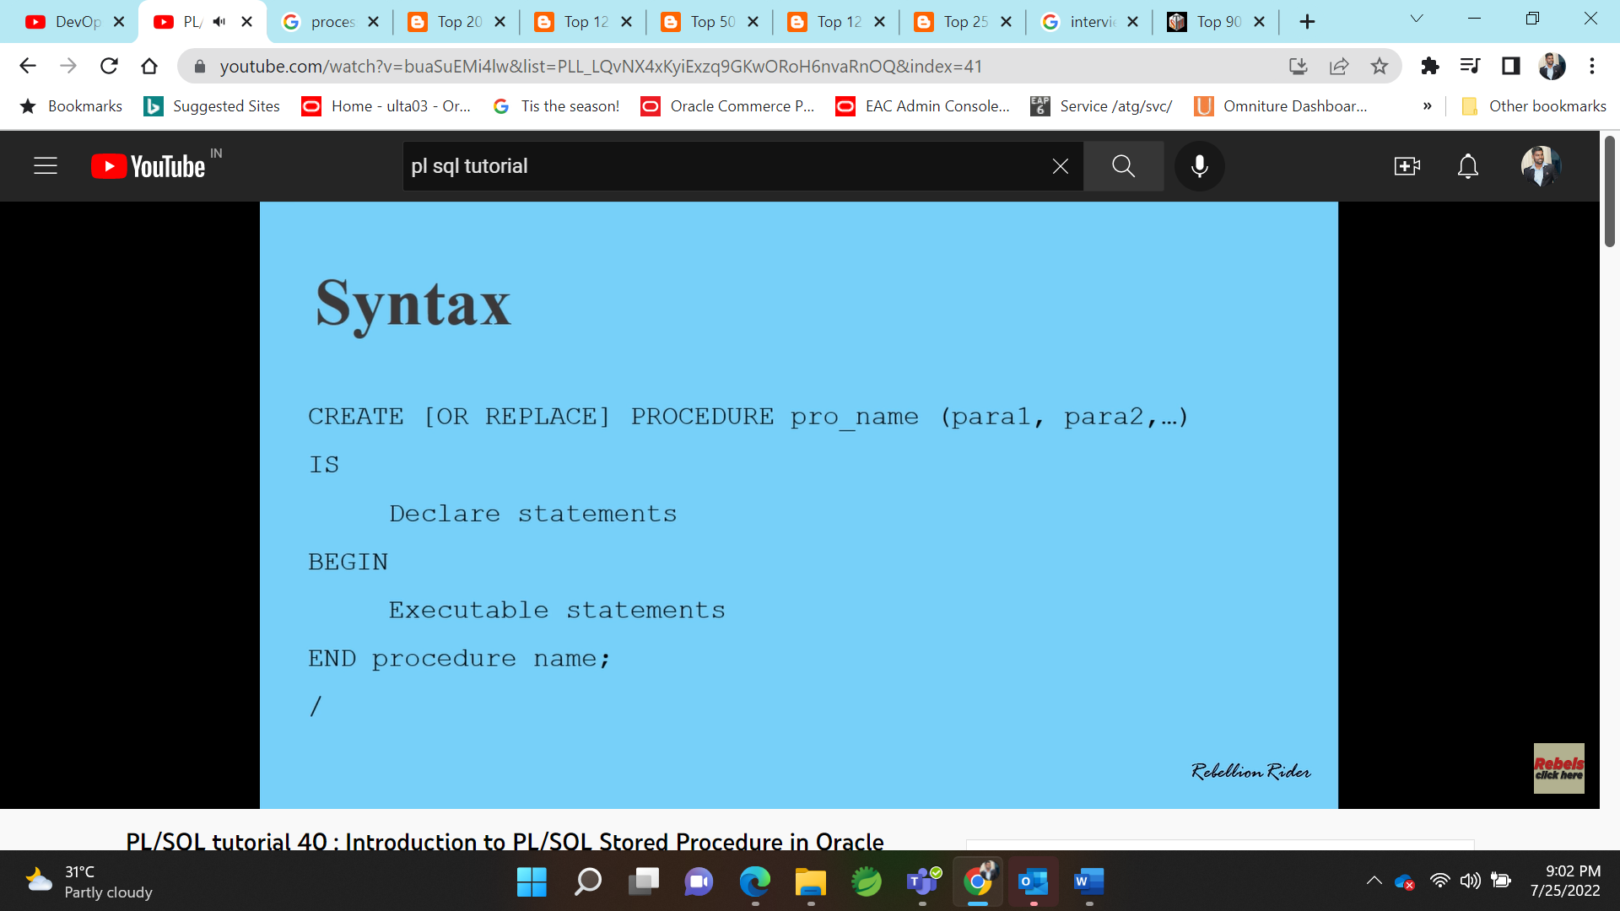

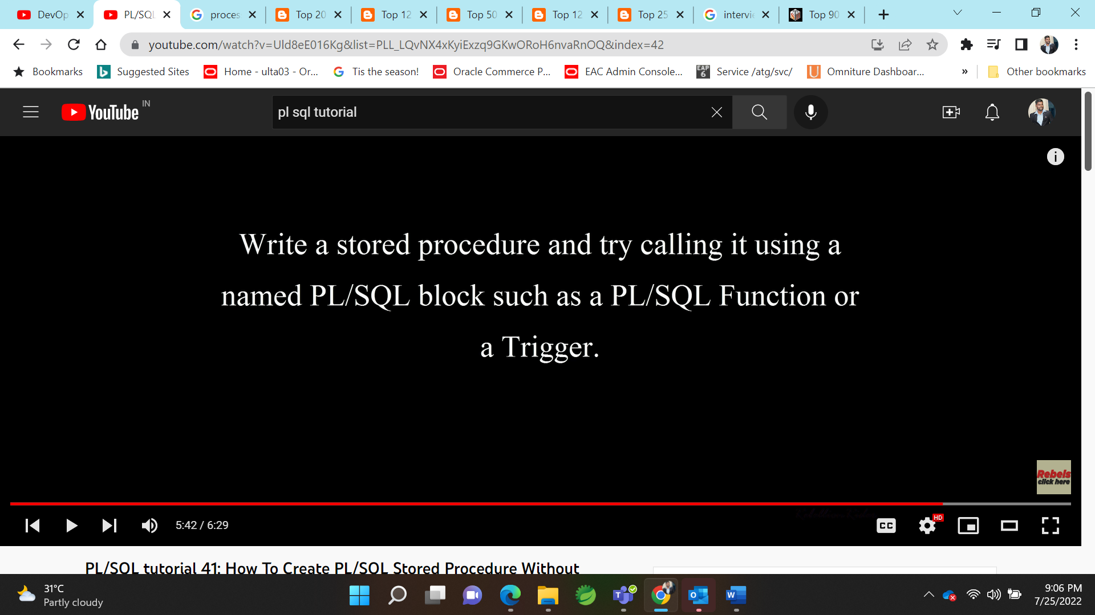

**What is an Index in Oracle?**

An index is a performance-tuning method of allowing faster retrieval of records. An index creates an entry for each value that appears in the indexed columns. By default, Oracle creates B-tree indexes.

**Create an Index**

Syntax

The syntax for creating an index in Oracle/PLSQL is:

CREATE [UNIQUE] INDEX index\_name

ON table\_name (column1, column2, ... column\_n)

[ COMPUTE STATISTICS ];

**UNIQUE**

It indicates that the combination of values in the indexed columns must be unique.

**index\_name**

The name to assign to the index.

**table\_name**

The name of the table in which to create the index.

**column1, column2, ... column\_n**

The columns to use in the index.

**COMPUTE STATISTICS**

It tells Oracle to collect statistics during the creation of the index. The statistics are then used by the optimizer to choose a "plan of execution" when SQL statements are executed.

Example

Let's look at an example of how to create an index in Oracle/PLSQL.

For example:

CREATE INDEX supplier\_idx

ON supplier (supplier\_name);

In this example, we've created an index on the supplier table called supplier\_idx. It consists of only one field - the supplier\_name field.

We could also create an index with more than one field as in the example below:

CREATE INDEX supplier\_idx

ON supplier (supplier\_name, city);

We could also choose to collect statistics upon creation of the index as follows:

CREATE INDEX supplier\_idx

ON supplier (supplier\_name, city)

COMPUTE STATISTICS;

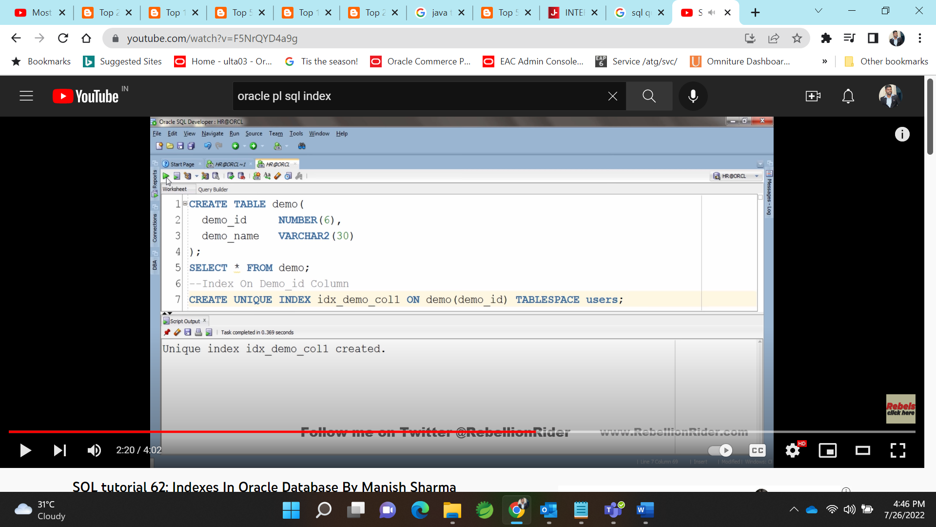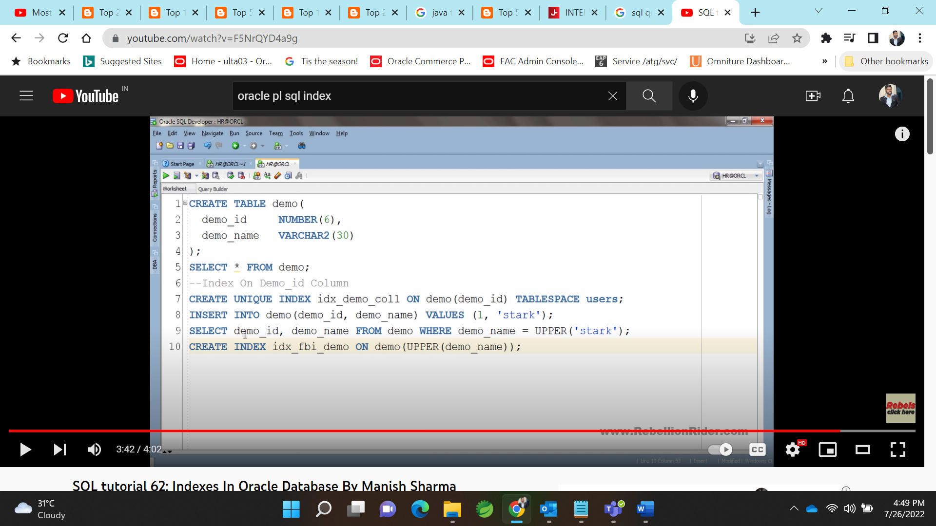

**BTREE index and function based index**

PL/SQL program units organize the code into blocks. A block without a name is known as an anonymous block. The anonymous block is the simplest unit in PL/SQL. It is called anonymous block because it is not saved in the Oracle database.

An anonymous block is an only one-time use and useful in certain situations such as creating test units. The following illustrates anonymous block syntax:

[DECLARE]

Declaration statements;

BEGIN

Execution statements;

[EXCEPTION]

Exception handling statements;

END;

/

Code language: SQL (Structured Query Language) (sql)

Let’s examine the PL/SQL block structure in greater detail.

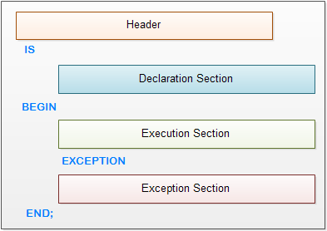PL/SQL Block Structure

EXCEPTIONs:

SET SERVEROUTPUT ON SIZE 100000;

DECLARE

-- define exceptions

BELOW\_SALARY\_RANGE EXCEPTION;

ABOVE\_SALARY\_RANGE EXCEPTION;

-- salary variables

n\_salary employees.salary%TYPE;

n\_min\_salary employees.salary%TYPE;

n\_max\_salary employees.salary%TYPE;

-- input employee id

n\_emp\_id employees.employee\_id%TYPE := &emp\_id;

BEGIN

SELECT salary,

min\_salary,

max\_salary

INTO n\_salary,

n\_min\_salary,

n\_max\_salary

FROM employees

INNER JOIN jobs ON jobs.job\_id = employees.job\_id

WHERE employee\_id = n\_emp\_id;

IF n\_salary < n\_min\_salary THEN

RAISE BELOW\_SALARY\_RANGE;

ELSIF n\_salary > n\_max\_salary THEN

RAISE ABOVE\_SALARY\_RANGE;

END IF;

dbms\_output.put\_line('Employee ' || n\_emp\_id ||

' has salary $' || n\_salary );

EXCEPTION

WHEN BELOW\_SALARY\_RANGE THEN

dbms\_output.put\_line('Employee ' || n\_emp\_id ||

' has salary below the salary range');

WHEN ABOVE\_SALARY\_RANGE THEN

dbms\_output.put\_line('Employee ' || n\_emp\_id ||

' has salary above the salary range');

WHEN NO\_DATA\_FOUND THEN

DBMS\_OUTPUT.PUT\_LINE('Employee ' || n\_emp\_id || ' not found');

END;

/

## Introducing to PL/SQL function

PL/SQL function is a named block that returns a value. A PL/SQL function is also known as a subroutine or a subprogram.

## Introducing to PL/SQL Cursor

When you work with Oracle database, you work with a complete set of rows returned from an SELECT statement. However the application in some cases cannot work effectively with the entire result set, therefore, the database server needs to provide a mechanism for the application to work with one row or a subset of the result set at a time. As the result, Oracle created PL/SQL cursor to provide these extensions.

A PL/SQL cursor is a pointer that points to the result set of an SQL query against database tables.

## Working with PL/SQL Cursor

The following picture describes steps that you need to follow when you work with a PL/SQL cursor:

[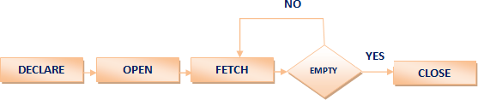](http://www.plsqltutorial.com/wp-content/uploads/2012/10/plsqlcursor.png)PL/SQL Cursor

Let’s examine each step in greater detail.

### Declaring PL/SQL Cursor

To use PL/SQL cursor, first you must declare it in the declaration section of [PL/SQL block](http://www.plsqltutorial.com/plsql-block-structure/) or in a [package](http://www.plsqltutorial.com/plsql-package/)as follows:

CURSOR cursor\_name [ ( [ parameter\_1 [, parameter\_2 ...] ) ]

[ RETURN return\_specification ]

IS sql\_select\_statements

[FOR UPDATE [OF [column\_list]];

Code language: SQL (Structured Query Language) (sql)

* First, you declare the name of the cursor cursor\_nameafter the CURSOR keyword. The name of the cursor can have up to 30 characters in length and follows the naming rules of identifiers in PL/SQL. It is important to note that cursor’s name is not a [variable](http://www.plsqltutorial.com/plsql-variables/)so you cannot use it as a variable such as assigning it to other cursor or using it in an expression. The  parameter1, parameter2… are optional elements in the cursor declaration. These parameters allow you to pass arguments into the cursor. The RETURN return\_specification is also an optional part.
* Second, you specify a valid SQL statement that returns a result set where the cursor points to.
* Third, you can indicate a list of columns that you want to update after the FOR UPDATE OF. This part is optional so you can omit it in the CURSOR declaration.

Here is an example of declaring a cursor:

CURSOR cur\_chief

IS

SELECT

first\_name, last\_name, department\_name

FROM

employees e

INNER JOIN departments d ON d.manager\_id = e.employee\_id;

Code language: SQL (Structured Query Language) (sql)

We retrieved data from employees and departments tables using the SELECTwith the INNER JOIN clause and set the cur\_chief cursor to this result set.

### Opening a PL/SQL Cursor

After declaring a cursor, you can open it by using the following syntax:

OPEN cursor\_name [ ( argument\_1 [, argument\_2 ...] ) ];

Code language: SQL (Structured Query Language) (sql)

You have to specify the cursor’s name cursor\_nameafter the keyword OPEN. If the cursor was defined with a parameter list, you need to pass corresponding arguments to the cursor.

When you OPEN the cursor, PL/SQL executes the SELECT statement and identifies the active result set. Notice that the OPENaction does not actually retrieve records from the database. It happens in the FETCHstep. If the cursor was declared with the FOR UPDATE clause, PL/SQL locks all the records in the result set.

We can open the cur\_chiefcursor as follows:

OPEN cur\_chief;

Code language: SQL (Structured Query Language) (sql)

### Fetching Records from PL/SQL Cursor

Once the cursor is open, you can fetch data from the cursor into a [record](http://www.plsqltutorial.com/plsql-record/)that has the same structure as the cursor. Instead of fetching data into a record, you can also fetch data from the cursor to a list of [variables](http://www.plsqltutorial.com/plsql-variables/).

The fetch action retrieves data and fills the record or the variable list. You can manipulate this data in memory. You can fetch the data until there is no record found in active result set.

The syntax of FETCHis as follows:

FETCH cursor\_name INTO record or variables

Code language: SQL (Structured Query Language) (sql)

You can test the cursor’s attribute %FOUND or %NOTFOUND to check if the fetch against the cursor is succeeded. The cursor has more  attributes that we will cover in the next section.

We can use [PL/SQL LOOP statement](http://www.plsqltutorial.com/plsql-loop-statement/) together with the FETCHto loop through all records in active result set as follows:

LOOP

-- fetch information from cursor into record

FETCH cur\_chief INTO r\_chief;

EXIT WHEN cur\_chief%NOTFOUND;

-- print department - chief

DBMS\_OUTPUT.PUT\_LINE(r\_chief.department\_name || ' - ' ||

r\_chief.first\_name || ',' ||

r\_chief.last\_name);

END LOOP;

Code language: SQL (Structured Query Language) (sql)

### Closing PL/SQL Cursor

You should always close the cursor when it is no longer used. Otherwise, you will have a memory leak in your program, which is not expected.

To close a cursor, you use CLOSEstatement as follows:

CLOSE cursor\_name;

Code language: SQL (Structured Query Language) (sql)

And here is an example of closing the cur\_chief cursor:

CLOSE cur\_chief;

Code language: SQL (Structured Query Language) (sql)

## A complete PL/SQL Cursor Example

The following is a complete example of cursor for printing a list of chief and name of departments as follows:

SET SERVEROUTPUT ON SIZE 1000000;

DECLARE

-- declare a cursor

CURSOR cur\_chief IS

SELECT first\_name,

last\_name,

department\_name

FROM employees e

INNER JOIN departments d ON d.manager\_id = e.employee\_id;

r\_chief cur\_chief%ROWTYPE;

BEGIN

OPEN cur\_chief;

LOOP

-- fetch information from cursor into record

FETCH cur\_chief INTO r\_chief;

EXIT WHEN cur\_chief%NOTFOUND;

-- print department - chief

DBMS\_OUTPUT.PUT\_LINE(r\_chief.department\_name || ' - ' ||

r\_chief.first\_name || ',' ||

r\_chief.last\_name);

END LOOP;

-- close cursor cur\_chief

CLOSE cur\_chief;

END;

/

Code language: SQL (Structured Query Language) (sql)

## PL/SQL Cursor Attributes

These are the main attributes of a PL/SQL cursor and their descriptions.

| **Attribute** | **Description** |
| --- | --- |
| cursor\_name%FOUND | returns TRUEif record was fetched successfully by cursor cursor\_name |
| cursor\_name%NOTFOUND | returns TRUEif record was not fetched successfully by cursor cursor\_name |
| cursor\_name%ROWCOUNT | returns the number of records fetched from the cursor cursor\_nameat the time we test %ROWCOUNT attribute |
| cursor\_name%ISOPEN | returns TRUEif the cursor cursor\_nameis open |

In this tutorial, you’ve learned how to use PL/SQL Cursor to loop through a set of rows with all necessary steps that need to be done including DECLARE, OPEN, FETCH and CLOSE.

# **PL/SQL Procedure**



**Summary**: in this tutorial, you will learn about **PL/SQL procedure**. We will show you how to create a PL/SQL procedure and how to call it.

## Introduction to PL/SQL Procedure

Like a [PL/SQL function](http://www.plsqltutorial.com/plsql-function/), a PL/SQL procedure is a named [block](http://www.plsqltutorial.com/plsql-block-structure/) that does a specific task. PL/SQL procedure allows you to encapsulate complex business logic and reuse it in both database layer and application layer.

The following illustrates the PL/SQL procedure’s syntax:

PROCEDURE [schema.]name[( parameter[, parameter...] ) ]

[AUTHID DEFINER | CURRENT\_USER]

IS

[--declarations statements]

BEGIN

--executable statements

[ EXCEPTION

---exception handlers]

END [name];

Code language: SQL (Structured Query Language) (sql)

Let’s examine the PL/SQL syntax in more detail. We can divide the PL/SQL procedure into two sections: header and body.

### PL/SQL Procedure Header

The section before IS keyword is called procedure header or procedure signature. The elements in the procedure’s header are described as follows:

* schema: the optional name of the schema that the procedure belongs to. The default is the current user. If you specify a different user, the current user must have privileges to create a procedure in that schema.
* name: The name of the procedure. The name of the procedure, by convention, should start with a verb e.g., put\_line
* parameters: the optional list of parameters. Please refer to the [PL/SQL function](http://www.plsqltutorial.com/plsql-function/) for more information on parameters with different modes IN, OUTand IN OUT.
* AUTHID: The optional AUHTIDdetermines whether the procedure will execute with the privileges of the owner ( DEFINER) of the procedure or with the privileges of the current user specified by CURRENT\_USER.

### PL/SQL Procedure Body

Everything after the ISkeyword is known as procedure body. The procedure body has similar syntax with an [anonymous block](http://www.plsqltutorial.com/plsql-block-structure/) which consists of the declaration, execution and exception sections.

The declaration and exception sections are optional. You must have at least one executable statement in the execution section. The execution section is the where you put the code to implement a given business logic to perform a specific task.

In PL/SQL procedure you can have a RETURN statement. However, unlike the RETURN statement in the [function](http://www.plsqltutorial.com/plsql-function/) that returns a value to calling program, the RETURN statement in the procedure is used only to halt the execution of the procedure and return control to the caller. The RETURNstatement in procedure does not take any expression or constant.

## Example of PL/SQL Procedure

We’re going to develop a procedure named adjust\_salary() in HR sample database provided by Oracle. We’ll update the salary information of employees in the employees table by using SQL UPDATE statement.

The following is the source code of the adjust\_salary() procedure :

CREATE OR REPLACE PROCEDURE adjust\_salary(

in\_employee\_id IN EMPLOYEES.EMPLOYEE\_ID%TYPE,

in\_percent IN NUMBER

) IS

BEGIN

-- update employee's salary

UPDATE employees

SET salary = salary + salary \* in\_percent / 100

WHERE employee\_id = in\_employee\_id;

END;

Code language: SQL (Structured Query Language) (sql)

How it works.

* The procedure has two parameters: IN\_EMPLOYEE\_ID and IN\_PERCENT.
* The procedure adjusts the salary of a particular employee specified the IN\_EMPLOYEE\_ID by a given percentage IN\_PERCENT.
* In the procedure body, we use the UPDATE statement to update the salary information.

Let’s take a look at how to call this procedure in various context.

## Calling PL/SQL Procedure

A procedure can call other procedures. A procedure without parameters can be called directly by using EXEC statement or EXECUTE statement followed by the name of the procedure as follows:

EXEC procedure\_name();

EXEC procedure\_name;

Code language: SQL (Structured Query Language) (sql)

A procedure with parameters can be called by using EXECor EXECUTEstatement followed by procedure’s name and its parameters in the order corresponding to the parameters list of the procedure as shown below:

EXEC procedure\_name(param1,param2…paramN);

Code language: SQL (Structured Query Language) (sql)

Now, we can call adjust\_salary()procedure as the following statements:

-- before adjustment

SELECT salary FROM employees WHERE employee\_id = 200;

-- call procedure

exec adjust\_salary(200,5);

-- after adjustment

SELECT salary FROM employees WHERE employee\_id = 200;

Code language: SQL (Structured Query Language) (sql)

In this tutorial, we have introduced you to PL/SQL procedure and shown you step by step how to develop and call a PL/SQL procedure that adjusts the salary of employees in the HR database.

# **SQL PARTITION BY Clause overview**

April 9, 2019 by [Rajendra Gupta](https://www.sqlshack.com/author/rajendra-gupta/)

[](https://www.apexsql.com/Download.aspx?utm_source=sqlshack&amp;utm_medium=banner&amp;utm_campaign=%5bSQLShack%5dApexSQLfreetoolstop)

This article will cover the SQL PARTITION BY clause and, in particular, the difference with GROUP BY in a select statement. We will also explore various use cases of SQL PARTITION BY.

We use [SQL PARTITION BY](https://www.quest.com/community/blogs/b/database-management/posts/when-and-how-to-use-the-sql-partition-by-clause) to divide the result set into partitions and perform computation on each subset of partitioned data.

## Preparing Sample Data

Let us create an Orders table in my sample database **SQLShackDemo** and insert records to write further queries.

|  |  |
| --- | --- |
| 1  2  3  4  5  6  7  8  9  10 | Use SQLShackDemo  Go  CREATE TABLE [dbo].[Orders]  (      [orderid] INT,      [Orderdate] DATE,      [CustomerName] VARCHAR(100),      [Customercity] VARCHAR(100),      [Orderamount] MONEY  ) |

I use [ApexSQL Generate](https://www.apexsql.com/sql-tools-generate.aspx" \t "_blank) to insert sample data into this article. Right click on the Orders table and **Generate test data**.

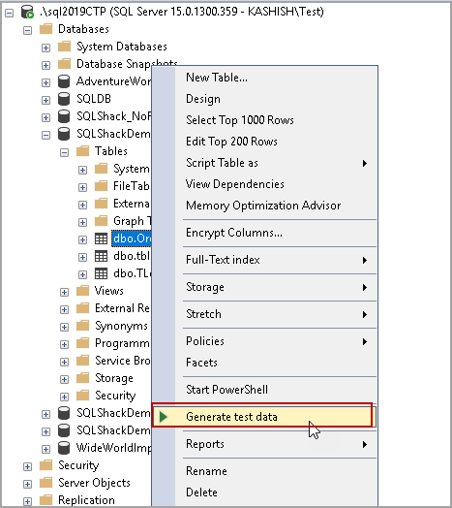

It launches the ApexSQL Generate. I generated a script to insert data into the Orders table. Execute this script to insert 100 records in the Orders table.

|  |  |
| --- | --- |
| 1  2  3  4  5  6  7 | USE [SQLShackDemo]  GO  INSERT [dbo].[Orders]  VALUES (216090, CAST(N'1826-12-19' AS Date), N'Edward', N'Phoenix', 4713.8900)  GO  INSERT [dbo].[Orders]  VALUES (508220, CAST(N'1826-12-09' AS Date), N'Aria', N'San Francisco', 9832.7200)  GO  … |

Once we execute insert statements, we can see the data in the Orders table in the following image.

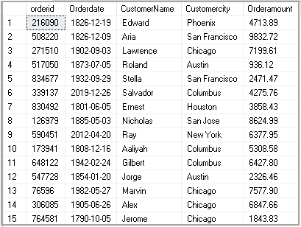

We use SQL GROUP BY clause to group results by specified column and use aggregate functions such as Avg(), Min(), Max() to calculate required values.

### Group By function syntax

|  |  |
| --- | --- |
| 1  2  3  4 | SELECT expression, aggregate function ()  FROM tables  WHERE conditions  GROUP BY expression |

Suppose we want to find the following values in the Orders table

* Minimum order value in a city
* Maximum order value in a city
* Average order value in a city

Execute the following query with GROUP BY clause to calculate these values.

|  |  |
| --- | --- |
| 1  2  3  4  5  6 | SELECT Customercity,         AVG(Orderamount) AS AvgOrderAmount,         MIN(OrderAmount) AS MinOrderAmount,         SUM(Orderamount) TotalOrderAmount  FROM [dbo].[Orders]  GROUP BY Customercity; |

In the following screenshot, we can see Average, Minimum and maximum values grouped by CustomerCity.

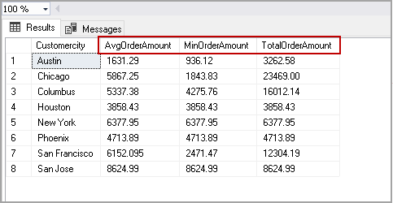

Now, we want to add **CustomerName** and **OrderAmount** column as well in the output. Let’s add these columns in the select statement and execute the following code.

|  |  |
| --- | --- |
| 1  2  3  4  5  6 | SELECT Customercity, CustomerName ,OrderAmount,         AVG(Orderamount) AS AvgOrderAmount,         MIN(OrderAmount) AS MinOrderAmount,         SUM(Orderamount) TotalOrderAmount  FROM [dbo].[Orders]  GROUP BY Customercity; |

Once we execute this query, we get an error message. In the SQL GROUP BY clause, we can use a column in the select statement if it is used in Group by clause as well. It does not allow any column in the select clause that is not part of GROUP BY clause.

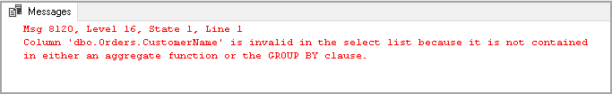

We can use the SQL PARTITION BY clause to resolve this issue. Let us explore it further in the next section.

### SQL PARTITION BY

We can use the **SQL PARTITION BY** clause with the **OVER** clause to specify the column on which we need to perform aggregation. In the previous example, we used Group By with CustomerCity column and calculated average, minimum and maximum values.

Let us rerun this scenario with the SQL PARTITION BY clause using the following query.

|  |  |
| --- | --- |
| 1  2  3  4  5 | SELECT Customercity,         AVG(Orderamount) OVER(PARTITION BY Customercity) AS AvgOrderAmount,         MIN(OrderAmount) OVER(PARTITION BY Customercity) AS MinOrderAmount,         SUM(Orderamount) OVER(PARTITION BY Customercity) TotalOrderAmount  FROM [dbo].[Orders]; |

In the output, we get aggregated values similar to a GROUP By clause. You might notice a difference in output of the SQL PARTITION BY and GROUP BY clause output.

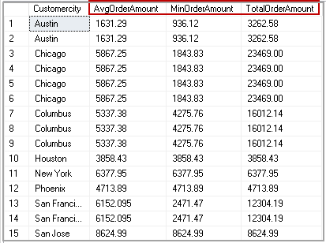

|  |  |
| --- | --- |
| **Group By** | **SQL PARTITION BY** |
| We get a limited number of records using the Group By clause | We get all records in a table using the PARTITION BY clause. |
| It gives one row per group in result set. For example, we get a result for each group of CustomerCity in the GROUP BY clause. | It gives aggregated columns with each record in the specified table.  We have 15 records in the Orders table. In the query output of SQL PARTITION BY, we also get 15 rows along with Min, Max and average values. |

In the previous example, we get an error message if we try to add a column that is not a part of the GROUP BY clause.

We can add required columns in a select statement with the SQL PARTITION BY clause. Let us add CustomerName and OrderAmount columns and execute the following query.

|  |  |
| --- | --- |
| 1  2  3  4  5  6  7 | SELECT Customercity,         CustomerName,         OrderAmount,         AVG(Orderamount) OVER(PARTITION BY Customercity) AS AvgOrderAmount,         MIN(OrderAmount) OVER(PARTITION BY Customercity) AS MinOrderAmount,         SUM(Orderamount) OVER(PARTITION BY Customercity) TotalOrderAmount  FROM [dbo].[Orders]; |

We get **CustomerName** and **OrderAmount**column along with the output of the aggregated function. We also get all rows available in the Orders table.

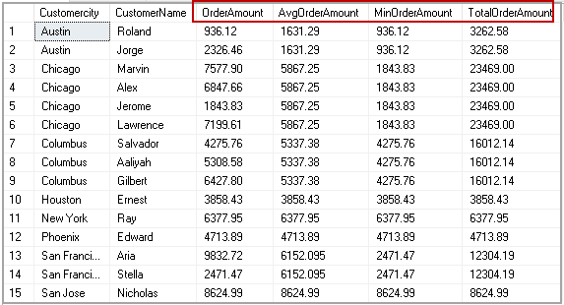

In the following screenshot, you can for CustomerCity **Chicago**, it performs aggregations (Avg, Min and Max) and gives values in respective columns.

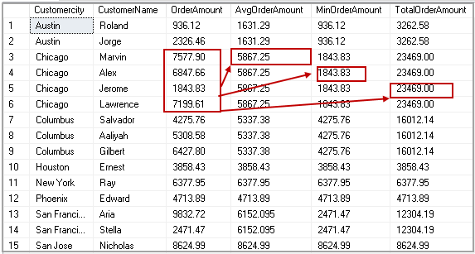

Similarly, we can use other aggregate functions such as count to find out total no of orders in a particular city with the SQL **PARTITION BY**clause.

|  |  |
| --- | --- |
| 1  2  3  4  5  6  7  8 | SELECT Customercity,         CustomerName,         OrderAmount,         COUNT(OrderID) OVER(PARTITION BY Customercity) AS CountOfOrders,         AVG(Orderamount) OVER(PARTITION BY Customercity) AS AvgOrderAmount,         MIN(OrderAmount) OVER(PARTITION BY Customercity) AS MinOrderAmount,         SUM(Orderamount) OVER(PARTITION BY Customercity) TotalOrderAmount  FROM [dbo].[Orders]; |

We can see order counts for a particular city. For example, we have two orders from Austin city therefore; it shows value 2 in **CountofOrders** column.

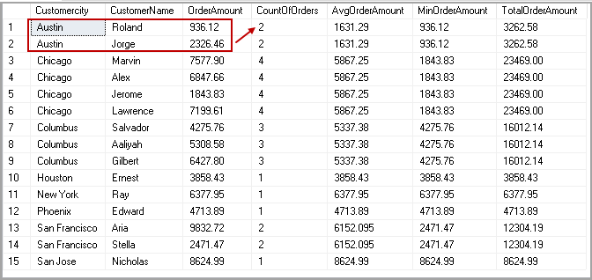

### PARTITION BY clause with ROW\_NUMBER()

We can use the SQL PARTITION BY clause with ROW\_NUMBER() function to have a row number of each row. We define the following parameters to use ROW\_NUMBER with the SQL PARTITION BY clause.

* **PARTITION BY column** – In this example, we want to partition data on **CustomerCity** column
* **Order By:**In the ORDER BY column, we define a column or condition that defines row number. In this example, we want to sort data on the **OrderAmount** column

|  |  |
| --- | --- |
| 1  2  3  4  5  6  7  8  9  10 | SELECT Customercity,         CustomerName,         ROW\_NUMBER() OVER(PARTITION BY Customercity         ORDER BY OrderAmount DESC) AS "Row Number",         OrderAmount,         COUNT(OrderID) OVER(PARTITION BY Customercity) AS CountOfOrders,         AVG(Orderamount) OVER(PARTITION BY Customercity) AS AvgOrderAmount,         MIN(OrderAmount) OVER(PARTITION BY Customercity) AS MinOrderAmount,         SUM(Orderamount) OVER(PARTITION BY Customercity) TotalOrderAmount  FROM [dbo].[Orders]; |

In the following screenshot, we get see for CustomerCity **Chicago**, we have Row number 1 for order with highest amount 7577.90. it provides row number with descending OrderAmount.

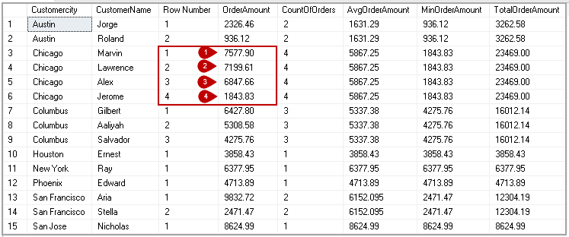

### PARTITION BY clause with Cumulative total value

Suppose we want to get a cumulative total for the orders in a partition. Cumulative total should be of the current row and the following row in the partition.

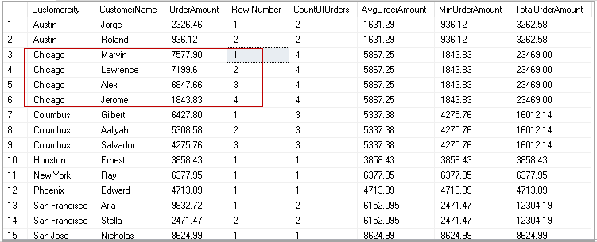

For example, in the Chicago city, we have four orders.

|  |  |  |  |  |  |
| --- | --- | --- | --- | --- | --- |
| CustomerCity | CustomerName | Rank | OrderAmount | Cumulative Total Rows | Cumulative Total |
| Chicago | Marvin | 1 | 7577.9 | Rank 1 +2 | 14777.51 |
| Chicago | Lawrence | 2 | 7199.61 | Rank 2+3 | 14047.21 |
| Chicago | Alex | 3 | 6847.66 | Rank 3+4 | 8691.49 |
| Chicago | Jerome | 4 | 1843.83 | Rank 4 | 1843.83 |

In the following query, we the specified **ROWS** clause to select the current row (using CURRENT ROW) and next row (using 1 FOLLOWING). It further calculates sum on those rows using sum(Orderamount) with a partition on CustomerCity ( using OVER(PARTITION BY Customercity ORDER BY OrderAmount DESC).

|  |  |
| --- | --- |
| 1  2  3  4  5  6  7 | SELECT Customercity,         CustomerName,         OrderAmount,         ROW\_NUMBER() OVER(PARTITION BY Customercity         ORDER BY OrderAmount DESC) AS "Row Number",         CONVERT(VARCHAR(20), SUM(orderamount) OVER(PARTITION BY Customercity         ORDER BY OrderAmount DESC ROWS BETWEEN CURRENT ROW AND 1 FOLLOWING), 1) AS CumulativeTotal, |

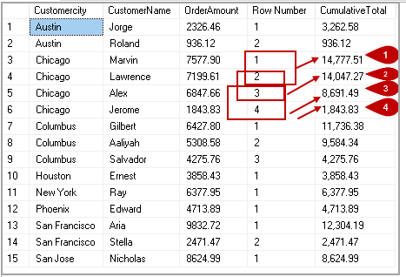

Similarly, we can calculate the cumulative average using the following query with the SQL**PARTITION BY** clause.

|  |  |
| --- | --- |
| 1  2  3  4  5  6  7 | SELECT Customercity,         CustomerName,         OrderAmount,         ROW\_NUMBER() OVER(PARTITION BY Customercity         ORDER BY OrderAmount DESC) AS "Row Number",         CONVERT(VARCHAR(20), AVG(orderamount) OVER(PARTITION BY Customercity         ORDER BY OrderAmount DESC ROWS BETWEEN CURRENT ROW AND 1 FOLLOWING), 1) AS CumulativeAVG |

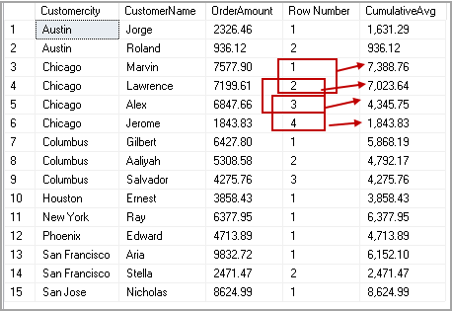

### ROWS UNBOUNDED PRECEDING with the PARTITION BY clause

We can use **ROWS UNBOUNDED PRECEDING** with the SQL PARTITION BY clause to select a row in a partition before the current row and the highest value row after current row.

In the following table, we can see for row 1; it does not have any row with a high value in this partition. Therefore, Cumulative average value is the same as of row 1 OrderAmount.

For Row2, It looks for current row value (7199.61) and highest value row 1(7577.9). It calculates the average for these two amounts.

For Row 3, it looks for current value (6847.66) and higher amount value than this value that is 7199.61 and 7577.90. It calculates the average of these and returns.

|  |  |  |  |  |  |
| --- | --- | --- | --- | --- | --- |
| CustomerCity | CustomerName | Rank | OrderAmount | Cumulative Average Rows | Cumulative Average |
| Chicago | Marvin | 1 | 7577.9 | Rank 1 | 7577.90 |
| Chicago | Lawrence | 2 | 7199.61 | Rank 1+2 | 7388.76 |
| Chicago | Alex | 3 | 6847.66 | Rank 1+2+3 | 7208.39 |
| Chicago | Jerome | 4 | 1843.83 | Rank 1+2+3+4 | 5867.25 |

Execute the following query to get this result with our sample data.

|  |  |
| --- | --- |
| 1  2  3  4  5  6  7  8 | SELECT Customercity,         CustomerName,         OrderAmount,         ROW\_NUMBER() OVER(PARTITION BY Customercity         ORDER BY OrderAmount DESC) AS "Row Number",         CONVERT(VARCHAR(20), AVG(orderamount) OVER(PARTITION BY Customercity         ORDER BY OrderAmount DESC ROWS UNBOUNDED PRECEDING), 1) AS CumulativeAvg  FROM [dbo].[Orders]; |

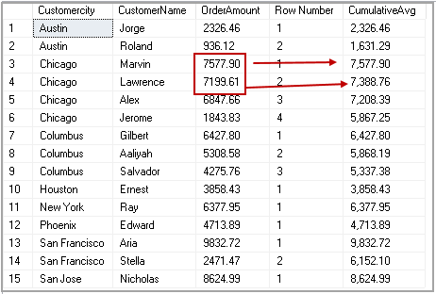

## Conclusion

In this article, we explored the SQL PARTIION BY clause and its comparison with GROUP BY clause. We also learned its usage with a few examples. I hope you find this article useful and feel free to ask any questions in the comments below

## See more

To boost SQL coding productivity, check out these [SQL tools](https://www.apexsql.com/prices.aspx?utm_source=sqlshack&utm_campaign=free&utm_medium=native_link&utm_content=sql-shack) for SSMS and Visual Studio including T-SQL formatting, refactoring, auto-complete, text and data search, snippets and auto-replacements, SQL code and object comparison, multi-db script comparison, object decryption and more

**Index** :

Function based index:

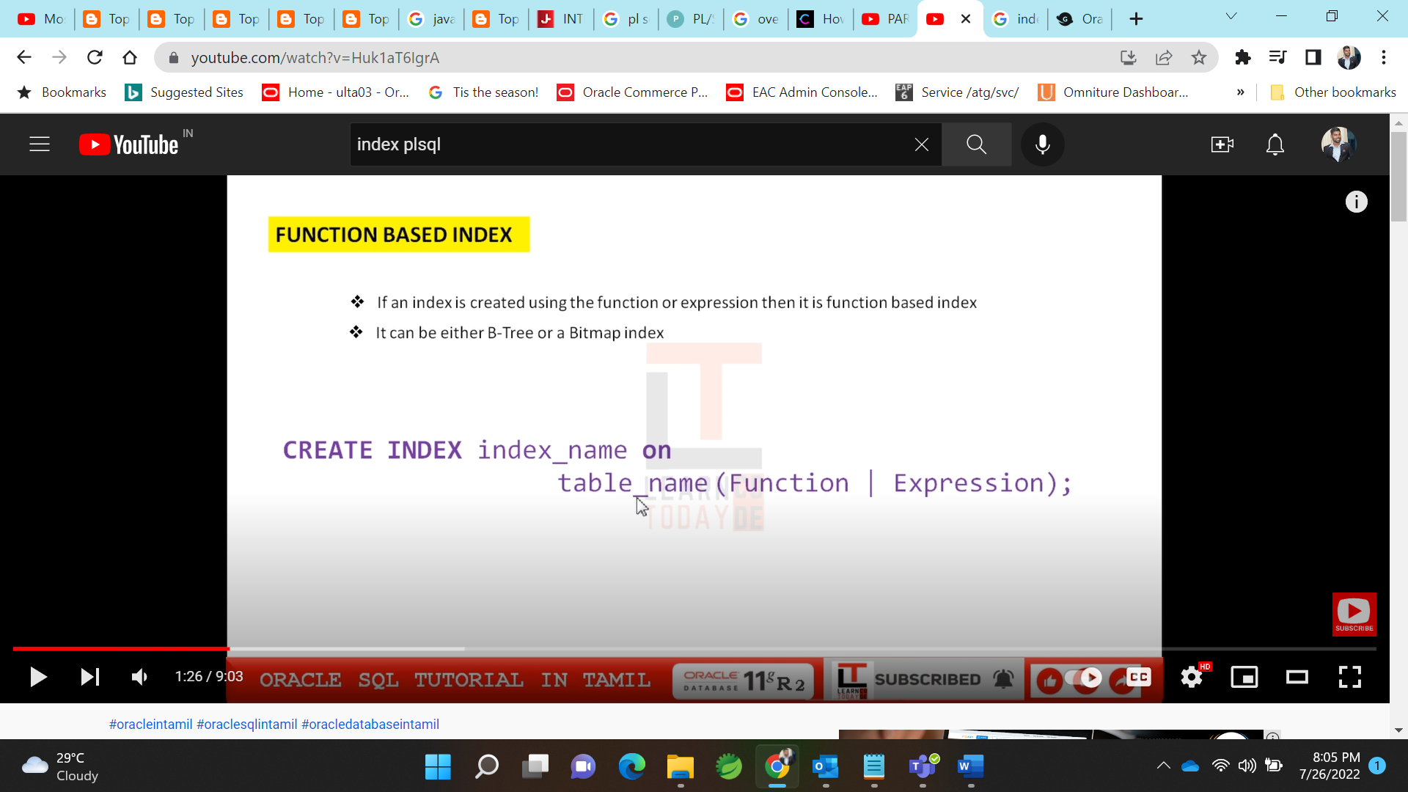

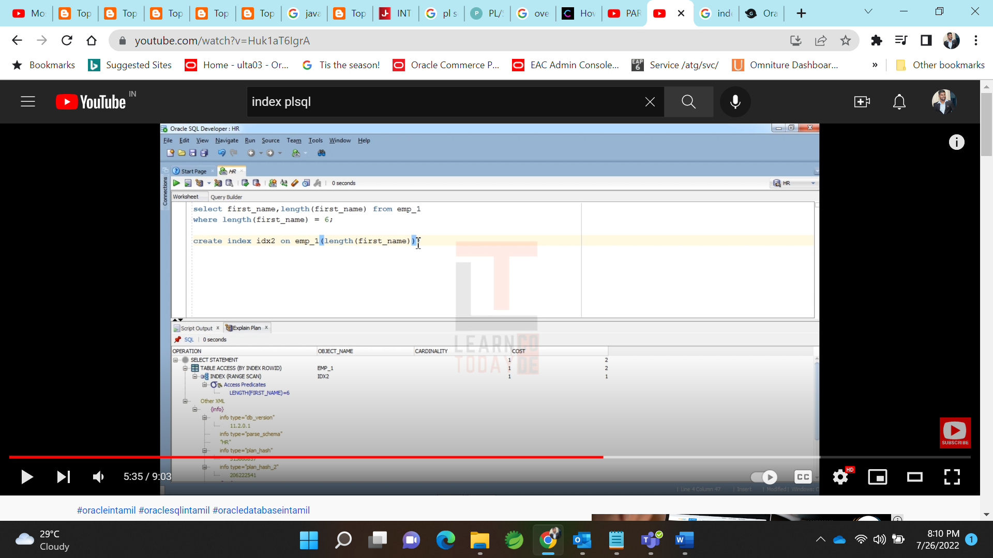

Expression index

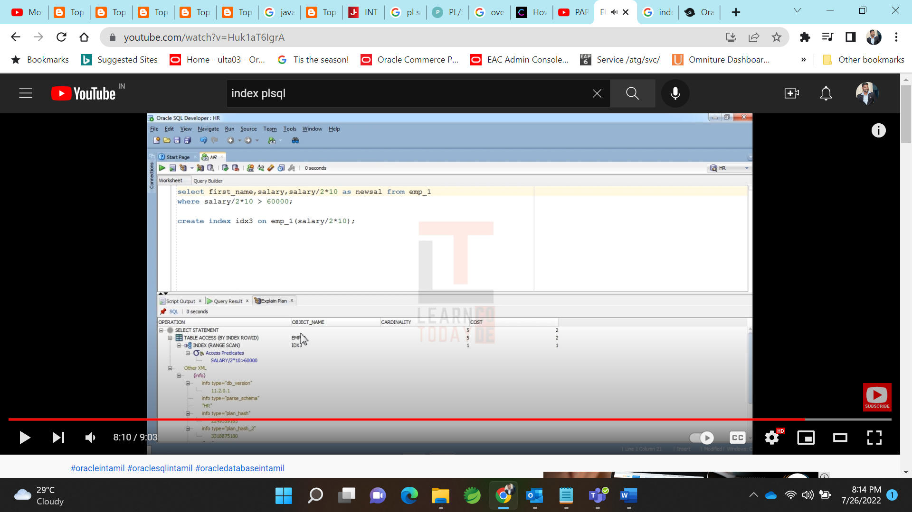

BTree Index:

--

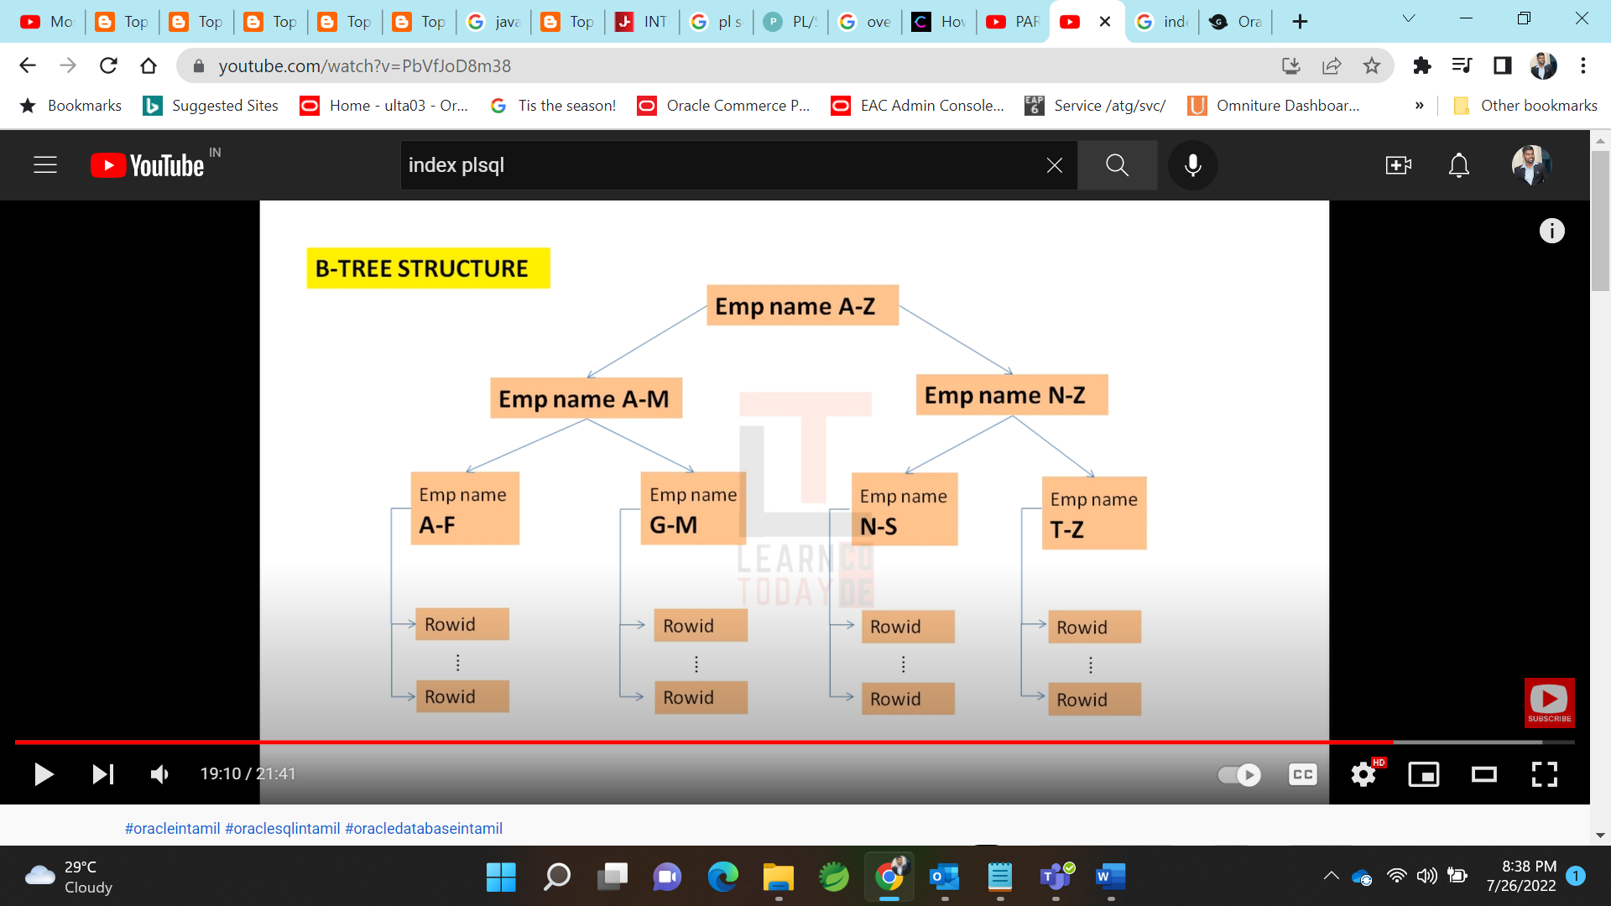

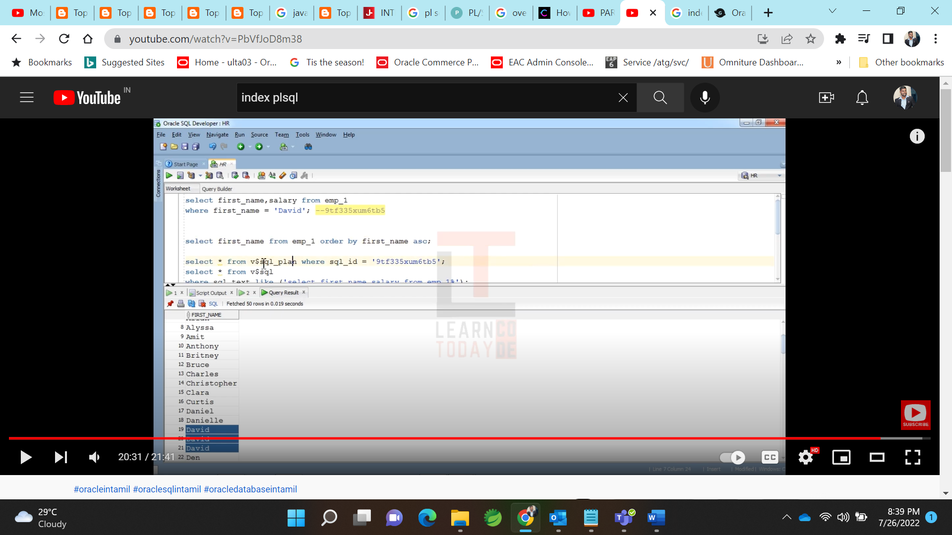

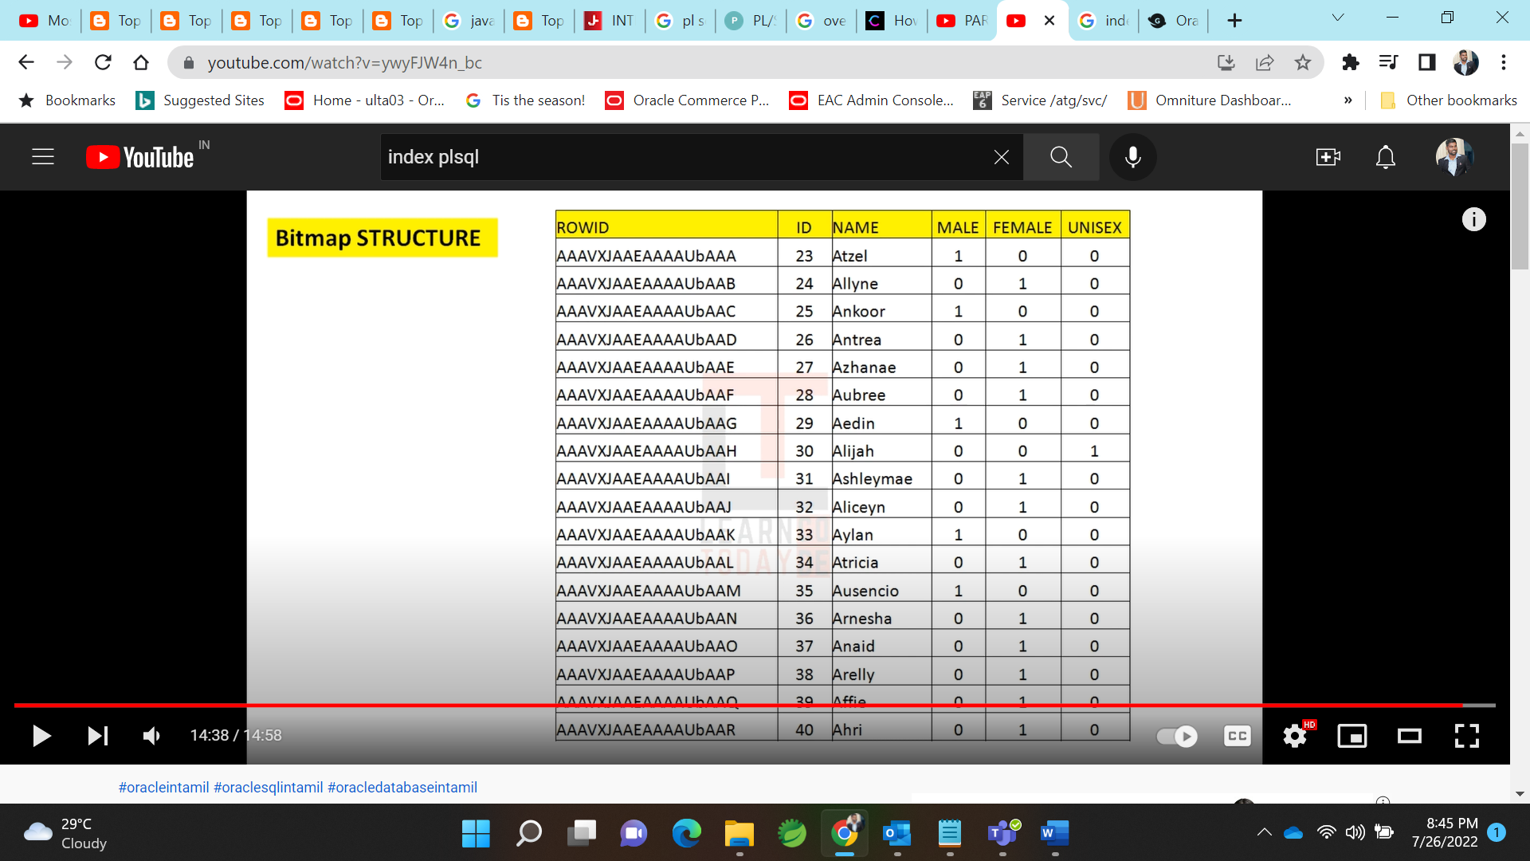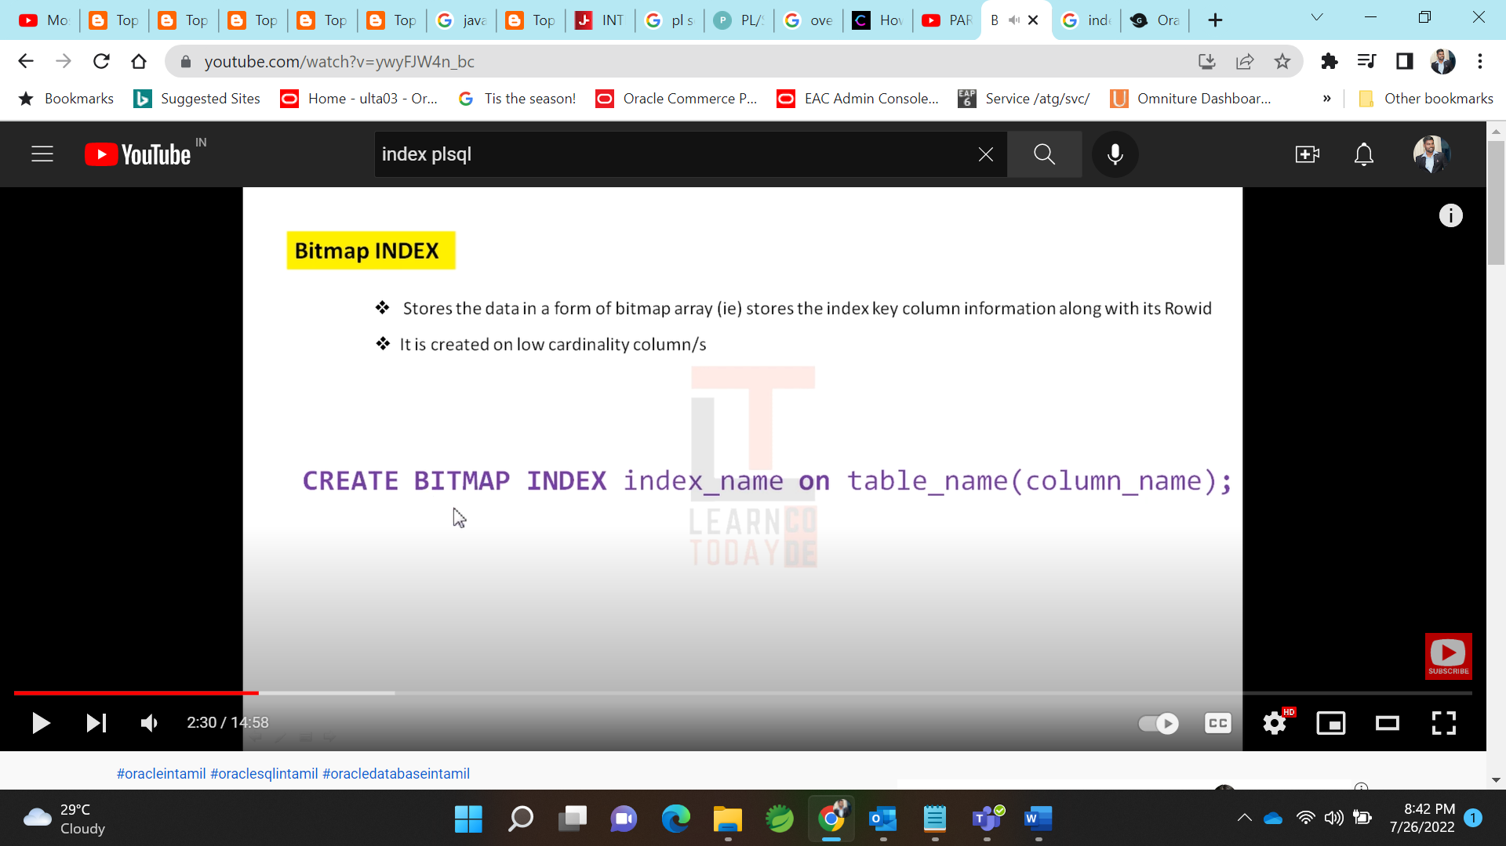

**Joins**: blog.quest.com/an-overview-of-sql-join-types-with-examples/

